Name: _________________________________ Date: ________________

Life Science Period: ______________

Cell Test Study Packet
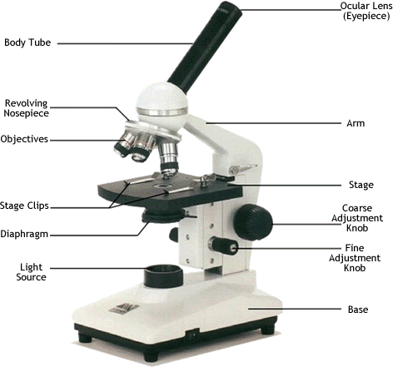
Microscope
- The _______________ is a piece of equipment that is used to view microscopic organisms at a higher magnification.
- The ocular lens of a microscope is set at a _____X magnification.
- The low objective lens is set at a _____X magnification.
- The medium objective lens is set at a _____X magnification.
- The high objective lens is set at a ____X magnification.
- The _______________ adjusts how much light shines through from the light source.
Hint: Think respiratory system.
- By adjusting the _________________________ the stage will lower or raise a lot to help focus the slide.
- When carrying a microscope one should always hold it by the _______________ and the _______________.
Hint: Only two kingdoms were realized before the discovery of the microscope.

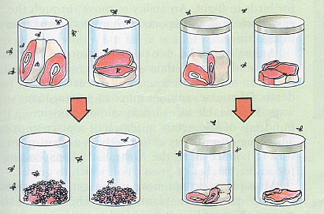
Cell Theory
- _______________ proved that all living organisms, such as maggots and flies, must come from other living things.
- _______________ learned that by heating a liquid to high temperatures one could destroy all unseen bacteria that may be living inside.
- The only characteristic that all living things share that proves cell theory is correct is _______________.
- Robert Hooke used one of the first microscopes to view cork up close and coined the phrase _______________ when talking about the tiny rooms he observed.

The Cell
- The smallest unit that can perform all the characteristics of living things is called a _______________.
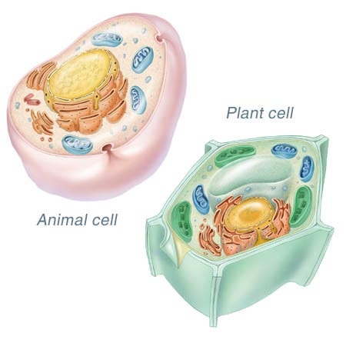
- In a eukaryotic cell, the genetic material is found in the _______________.
- A _______________ is less complex than a eukaryotic cell because it does not have a nucleus.
- If a cell has a square or rectangular shape, it is most likely a _______________ cell.

Organelles
- A plant cell has both a cell wall and a _______________, but an animal cell only has one of these.
- _______________ is the organelle found in plant cells that use sunlight to create energy in the form of sugar.
- The hard _______________ helps give plants cells and the entire organism the strength to stand up to harsh winds and storms.
- The structure used in both plant and animal cells to store water and nutrients is the _______________.
- The _______________ controls what materials will be absorbed into the cell.
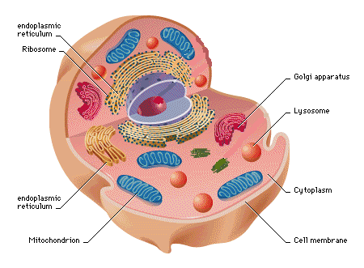
- The pancake like _______________ packages and processes proteins made by the cell.
- The ____________________ are tube-like structures that transport materials throughout the cell.
- The _______________ is used to break down large proteins and material inside the cell.
Hint: Know your animal cell organelles.

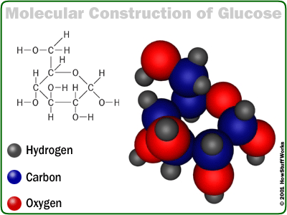
Big Molecules
- _______________ are the fats, oils and waxes that are found in all living things.
- The reason meats, eggs, cheese and some beans are important to a healthy diet is because they are all a good source of _______________.
- _______________ are used for energy storage and for energy when broken down in chemical reactions.
- Two examples of carbohydrates are _______________ and _______________.
- _______________ is a complex carbohydrate that is used in the cell wall in plant cells.
- _______________ is a sugar molecule that many living things use to release energy.

Transport
- _______________ is a process that uses oxygen to release energy stored in cell.
- When a cell uses energy to move materials through its membrane that is called _______________.
- When material is passed through a cell without using any energy that is called _______________.
- _______________ is when a liquid diffuses through a membrane.
- In_______________, a membrane within the cell encloses the material that needs to be removed, pushing it out of the cell.
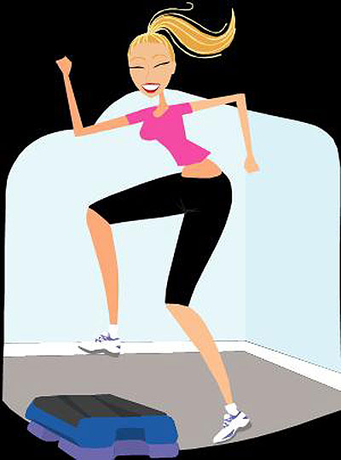
- _______________ occurs when a large bit of material is captured within a pocket of the membrane.

Release Energy
- The term aerobic refers to the usage of _______________.
Hint: What do you use a lot of while doing aerobics?
- The two products of photosynthesis are _______________ and _______________.
- The three products of cellular respiration are _______________, _______________ and _______________.
- Lactic acid fermentation is used to create _______________ and _______________.
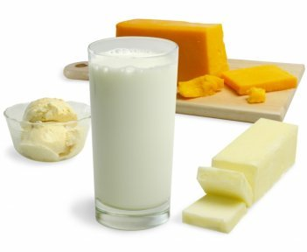
Hint: Lactose intolerant people can’t digest dairy products.
- Alcoholic fermentation is used to create _______________ and _______________.
- Compared to fresh water, ocean water has a __________ concentration of salt.
- _______________ is made up of one atom of carbon and two atoms of oxygen.
- Water is made up of __________ atoms of hydrogen and __________ atoms of oxygen.
- C6H12O6 is the molecular formula for _______________.

