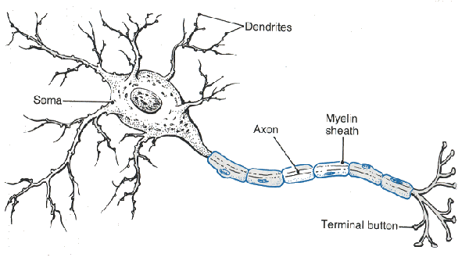
Label the diagram and state each parts function.
- Explain depolarization and an action potential.
- Explain how neurons communicate- use synapse and neurotransmitter in your answer.
- Explain reuptake.
- What do dopamine and serotonin do?

