Biology
Chapter 3 Test
Study Guide

Name____________________________ Date_____________________ Period_______

Use the following information to help you prepare for the Chapter 3 Test.

- What happens to energy as it moves through a food chain? How much of the energy is passed on to each level? What happens to the energy that is not passed on to the next trophic level?

- A bird kills and eats an insect. What kind of organism is it?

- What role does algae play in a food chain?

- What is a food web?

- What is an organism that uses energy to make its own food?

- What is the water cycle?

- What is recycled in the biosphere? What is not?

- How is the movement of energy different from the movement of nutrients in the biosphere?

- What is the order of how energy is transferred in a food chain?

- What is the original source of energy in most ecosystems?

- An organism that eats another carnivore that has eaten a herbivore is called_____.

- Determine how specific changes in a food web would affect the other organisms in the food web.

- Read and interpret a diagram of the carbon cycle.

- What role do plants play in an ecosystem?

- What is a heterotroph?

- Know the difference between an omnivore, herbivore, carnivore and detritivore.

- Why does biomass decrease from one level to another in an ecosystem?

- What are nitrogen fixing bacteria? What role do they play in the nitrogen cycle?

- Be able to explain, in detail, an energy pyramid. Know how much energy is available at each trophic level. What organisms would you find at each level in the pyramid? What is biomass? Where would you find decomposers in an energy pyramid? Explain why.

- Examples of food web questions:

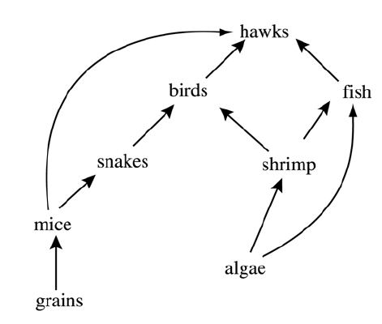
Examine the food web above. If the fish population suddenly decreased, the mouse population would also decline because mice would -

a. | have less available oxygen
b. | fill the same niche as the fish
c. | be deprived of a source of food
d. | face increased predation by hawks

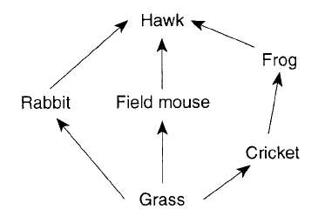
Which statement best describes a direct result of a decrease in the rabbit population due to disease?

a. | The hawk population will increase
b. | The grass population will increase
c. | The cricket population will decrease
d. | The frog population will be eliminated

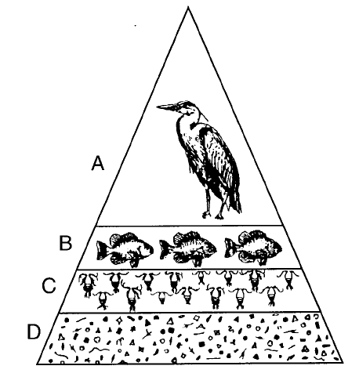
Which statement best describes one of the levels of this pyramid?

a. | Level A contains the largest producers in the pyramid
b. | The organisms in level B obtain food directly from level A.
c. | Level C contains the largest group of consumers in the pyramid.
d. | Level D contains the greatest number of heterotrophs in the pyramid

The action of decomposers in the nitrogen cycles most directly aids in the

a. | synthesis of proteins from nitrates
b. | removal of nitrogen compounds from the atmosphere
c. | restoration of nitrogen compounds to the soil
d. | fixation of atmospheric nitrogen

