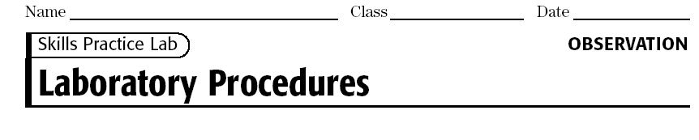
The best way to become familiar with chemical apparatus is to handle the pieces
yourself in the laboratory. This experiment is divided into several parts in which
you will learn how to adjust the gas burner, use a balance, handle solids, measure liquids, and filter a mixture. Great emphasis is placed on safety precautions that should be observed whenever you perform an experiment and use the apparatus. In many of the later experiments, references will be made to these “Laboratory Techniques.” In later experiments
you will also be referred to the safety precautions and procedures explained in all
parts of this experiment. It is important that you develop a positive approach to a
safe and healthful environment in the lab.
OBJECTIVES
Observe proper safety techniques with all laboratory equipment.
Use laboratory apparatus skillfully and efficiently.
Recognize the names and functions of all apparatus in the laboratory.
Develop a positive approach toward laboratory safety.
PART 1—THE BURNER
MATERIALS

• Bunsen burner and related equipment
• copper wire, 18 gauge
• evaporating dish
• forceps
• heat-resistant gloves
• heat-resistant mat
• lab apron
• safety goggles
• sparker

Procedure
1. Put on safety goggles, and a lab apron.
2. The Bunsen burner is commonly used as a source of heat in the laboratory. Look at Figure 1 as you examine your Bunsen burner and identify the parts. Although the details of construction vary among burners, each has a gas inlet located in the base, a vertical tube or barrel in which the gas is mixed with air, and adjustable openings or ports in the base of the barrel. These ports admit air to the gas stream. The burner may have an adjustable needle valve to regulate the flow of gas. In some models the gas flow is regulated simply by
adjusting the gas valve on the supply line. The burner is always turned off at the gas valve, never at the needle valve.
CAUTION: Before you light the burner, check to see that you and your partner have taken the following safety precautions against fires: Wear safety goggles and aprons. Confine long hair and loose clothing: tie long hair at the back of the head and away from the front of the face, and roll up long sleeves on shirts, blouses, and sweaters away from the wrists. You should also know the locations of fire extinguishers and safety showers and the procedure for using them in case of a fire.
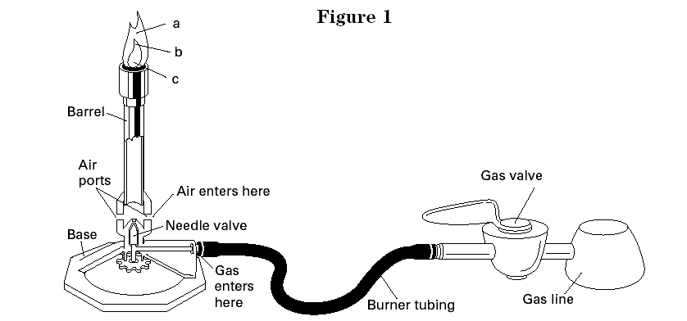
Menu Lesson Print
Figure 1
3. When lighting the burner, partially close the ports at the base of the barrel, turn the gas full on, hold the sparker about 5 cm above the top of the burner, and proceed to light. The gas flow may then be regulated by adjusting the gas valve until the flame has the desired height. If a very low flame is needed, remember that the ports should be partially closed when the gas pressure is reduced. Otherwise the flame may burn inside the base of the barrel. When
the flame is improperly burning in this way, the barrel will get very hot, and the flame will produce a poisonous gas, carbon monoxide.
CAUTION: If the flame is burning inside the base of the barrel, immediately
turn off the gas at the gas valve. Do not touch the barrel, because it is extremely hot. Allow the barrel of the burner to cool, and then proceed as follows:
Begin again, but first decrease the amount of air admitted to the burner by partially closing the ports. Turn the gas full on, and then relight the burner. Control the height of the flame by adjusting the gas valve. By taking these steps, you should acquire a flame that is burning safely and is easily regulated.

4. Once you have a flame that is burning safely and steadily, you can experiment by completely closing the ports at the base of the burner. What effect does this have on the flame?
___________________________________________________________________________________________________________________________________________________________________________________________________________________________________________________________________________________________________________
Menu Lesson Print

5. Regulate the flow of gas so that the flame extends roughly 8 cm above the barrel. Now adjust the supply of air until you have a noisy, steady flame with a sharply defined, light-blue inner cone. This adjustment gives the highest temperature possible with your burner. Using the forceps, insert a 10-cm piece of copper wire into the flame just above the barrel. Lift the wire slowly up through parts of the flame. Where is the hottest portion of the flame located?
_____________________________________________________________________________________________________________________________________________________
Hold the wire in this part of the flame for a few seconds. What happens?
______________________________________________________________________________________________________________________________________________________
6. Shut off the gas burner. Now think about what you have just observed in steps 4 and 5. Why is the nonluminous flame preferred over the yellow luminous flame in the laboratory?
_________________________________________________________________________________________________________________________________________________________________________________________________________________________________
7. Put away the burner. All the equipment you store in the lab locker or drawer should be completely cool, clean, and dry. Be sure that the valve on the gas jet is completely shut off. Remember to wash your hands thoroughly with soap at the end of each laboratory period.

PART 2—HANDLING SOLIDS
MATERIALS

• weighing tray
• gloves
• lab apron
• safety goggles
• fine sand
• spatula
• test tube

Procedure
1. Solids are usually kept in wide-mouthed bottles. A spatula should be used to dip out the solid as shown in Figure 3.
CAUTION: Do not touch chemicals with your hands. Some chemical reagents readily pass through the skin into the bloodstream and can cause serious health problems. Some chemicals are corrosive. Always wear an apron and safety goggles when handling chemicals. Carefully check the label on the reagent bottle or container before removing any of the contents. Never use more of a chemical than directed. You should also know the locations of the emergency lab shower and eyewash station and the procedures for using them in case of an accident.
Using a spatula, remove a quantity of fine sand from its reagent bottle. In order to transfer the sand to a test tube, first place it on a weigh tray about 10 cm square. Fold the tray in half and slide it into a test tube that is lying flat on the table. When you lift the tube to a vertical position and tap the tray gently, the solid will slide down into the test tube, as shown in Figure 4.
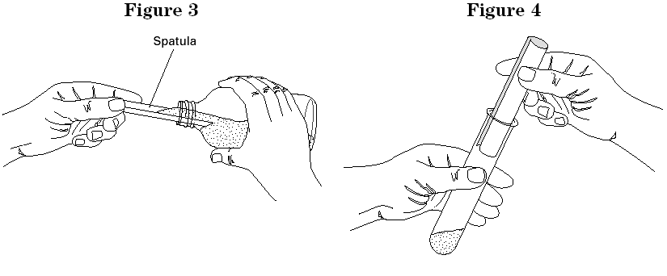

CAUTION: Never try to pour a solid from a bottle into a test tube. As a precaution against contamination, never pour unused chemicals back into their reagent bottles.

PART 3—THE BALANCE
MATERIALS

• balance, centigram
• gloves
• lab apron
• safety goggles
• sodium chloride
• spatula
• weighing tray

Procedure
1. When a balance is required for determining mass, you will use a electronic balance. The balance has a readability of 0.1 g. This means that your mass readings should all be recorded to the nearest 0.1 g.
2. Before using the balance, always check to see if the display is at zero. If the pointer is not at zero, press the TARE button. Never place chemicals or hot objects directly on the balance pan. Always use weighing trays or a glass container. Chemicals can permanently damage the surface of the balance pan and affect the accuracy of measurements.
3. In many experiments, you will be asked to determine the mass of a specified amount of a chemical solid. Use the following procedure to obtain approximately 2.0 g of sodium chloride.
a. Make sure that the balance is set at zero. Obtain a weighing tray and place it on the balance pan. Zero out the mass of the tray by pressing the TARE button after placing the empty tray on the pan.
b.Using a spatula, obtain a quantity of sodium chloride from the reagent
bottle and place it on a separate weighing tray.
c. Now slowly pour the sodium chloride from the tray onto the
weighing tray on the balance pan until the display reads the required amount. In most cases, you will only have to be close to the specified mass. Do not waste time trying to obtain exactly 2.0 g. Instead, read the exact mass. The mass might be 2.18 g. Record your exact
mass of sodium chloride to the nearest 0.1 g.
Mass of NaCl and weigh tray: _______________________

4. Obtain a sample of fine sand with a mass of 2.0 grams.
5. Save the samples of sand and sodium chloride for the next part of the lab.

PART 4—FILTRATION
MATERIALS

• beaker, 250 mL (2)
• Bunsen burner and related equipment
• evaporating dish
• filter paper
• fine sand
• funnel
• glass stirring rod
• gloves
• iron ring
• lab apron
• ring stand
• safety goggles
• sodium chloride
• sparker
• wash bottle
• water
• wire gauze,
ceramic-centered

Procedure Figure 10

- Dissolve the 2.0g of sodium chloride in a beaker containing about 30 mL of water, and then stir into the solution the sample of fine sand.
- Sometimes liquids contain particles of insoluble solids that
are present either as impurities or as precipitates formed
by the interaction of the chemicals used in the experiment. If
the particles are denser than water, they soon sink to the
bottom. Most of the clear, supernatant liquid above the
solid may be poured off without disturbing the precipitate. This method of
separation is known as decantation. Fine particles, or particles that settle slowly, are often separated from a liquid by filtration.

- Working in your lab team design a procedure to separate the mixture of water, sand and sodium chloride that you just made. Use the diagrams in the lab to help you. Write the detailed procedure that you create on a separate sheet of paper. Check your procedure with the teacher and obtain approval to proceed. Follow the procedure and complete the separation.
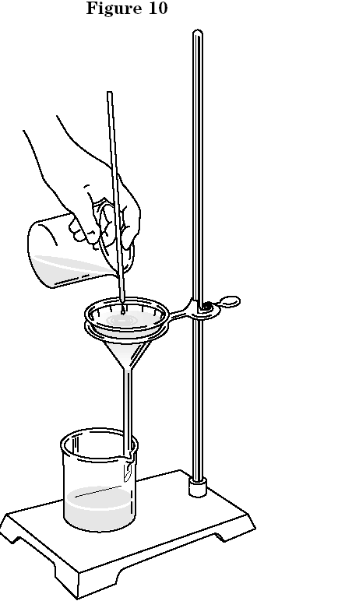
  - Include proper scientific terminology
  - Measure the amount of sand and sodium chloride you recover.
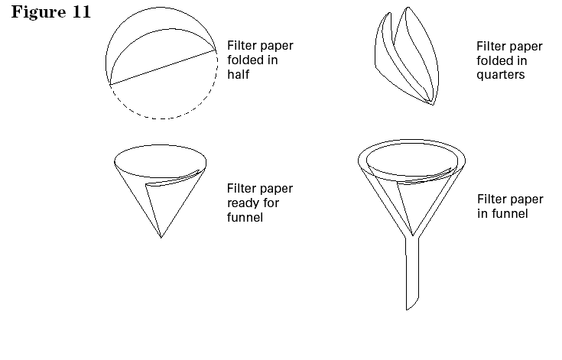

What property of the sand enables it to be separated from the water by filtration? ______________________________________________________________________________________________________________________________________________________
What does the filtrate contain?
___________________________________________________________________________

5. The salt can be recovered from the filtrate by evaporation . Figure 12 shows a correct setup for evaporation.
CAUTION: When using a Bunsen burner, confine loose clothing and long hair. Wear your safety goggles, and lab apron.

What property of the salt prevents it from being separated from the water by filtration?____________________
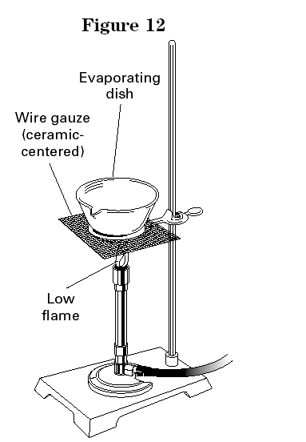
______________________________________

7. All equipment should be clean, dry, and put
away in an orderly fashion for the next lab
experiment. Be sure that the valve on the gas jet
is completely shut off. Make certain that the
filter papers and sand are disposed of in the
waste jars or containers and not down the sink.
Remember to wash your hands thoroughly with
soap at the end of each laboratory period.

Name________________
Analysis
Answer the following questions in complete sentences.
1. Organizing Ideas As soon as you enter the lab, what safety equipment should you put on immediately?
_____________________________________________________________________________________________________________________________________________________
2. Organizing Ideas Before doing an experiment, what should you read and discuss with your teacher?
______________________________________________________________________________________________________________________________________________________
3. Organizing Ideas Before you light a burner, what safety precautions should always be followed?
____________________________________________________________________________________________________________________________________________________________________________________________________________________________________________________________________________________________________________
4. Organizing Ideas What immediate action should you take when the flame of your burner is burning inside the base of the barrel?
____________________________________________________________________________________________________________________________________________________________________________
5. Organizing Ideas What type of flame is preferred for laboratory work, and why?
______________________________________________________________________________________________________________________________________________________
6. Analyzing Ideas Why are broken glassware, chemicals, matches, and other laboratory debris never discarded in a wastepaper basket?
_____________________________________________________________________________________________________________________________________________________
Menu Lesson Print
7. Analyzing Ideas Why should you never touch chemicals with your hands?
______________________________________________________________________________________________________________________________________________________
8. Organizing Ideas What precaution can help prevent chemical contamination in reagent bottles?
_________________________________________________________________________________________________________________________________________________________________________________________________________________________________
9. Analyzing Ideas Why are chemicals and hot objects never placed directly on the balance pan?
_________________________________________________________________________________________________________________________________________________________________________________________________________________________________
10. Organizing Ideas What is the rule about the size of filter paper to be used with a funnel? _________________________________________________________________________________________________________________________________________________________________________________________________________________________________

11. Organizing Ideas How can a liquid be transferred from a beaker to a funnel without spattering and without running down the outside wall of the beaker?
_________________________________________________________________________________________________________________________________________________________________________________________________________________________________
Menu Lesson Print
12. Organizing Ideas Describe the condition of all lab equipment at the end of an experiment. What should be checked before you leave the lab?
______________________________________________________________________________________________________________________________________________________
13. Organizing Ideas What is the correct procedure for removing a solid reagent from its container in preparation for its use in an experiment?
_________________________________________________________________________________________________________________________________________________________________________________________________________________________________
14. Organizing Ideas What is the correct procedure for removing a liquid reagent from its container in preparation for its use in an experiment?
_________________________________________________________________________________________________________________________________________________________________________________________________________________________________
15. Analyzing Ideas Why is it important to use low flame when evaporating water from a recovered filtrate?
_________________________________________________________________________________________________________________________________________________________________________________________________________________________________

