Welcome! | 7th Grade Life Science  Class Requirements & Expectations  Mr. Harrington~ HMS Rm 241  http://www.hackensackschools.org/webpages/tharrington/

Welcome to 7th grade Life Science! This year will be one of both learning and fun, as we explore the world of living things and their surroundings. Throughout the year, I hope to provide both a positive and safe learning environment. This can only be accomplished with your help. Our ultimate goal is to have both personal and academic growth.

The content area of science is the tool being used to help you develop and improve your life skills. The demands that I place on you, both as people and as students, will help you to grow in the areas of responsibility, balancing, prioritizing, dealing with stress, dealing with success and failure, communicating and interacting in a positive manner. These are skills that we all need to succeed in the world.
Grading

- Tests – Given at the conclusion of each unit, Unit Assessments are administered to determine mastery of content covered. Unit tests are always announced at least one week in advance.
- Quizzes and Labs – Quizzes are administered regularly (approx. once a week), can be in a variety of formats, and may or may not be announced.
- Projects – Each unit will incorporate a project that should be completed with maximum effort. Unit projects will be introduced at the beginning of the unit, and submitted on the given deadline.
- Homework – Students will be provided with weekly non-fiction non-text science articles to read and complete written work on. Articles are distributed on Mondays, with associated work collected each Friday. Other smaller assignments will be given throughout the week as well.
- Science Notebooks – All current science work will be brought to class daily in a one-inch 3 ring binder. A log of all work completed will be kept in the front of the binder, and each student will be graded according to how well the notebook reflects the work completed in the unit. Notebooks are stapled together and collected on the day of each Unit Test.
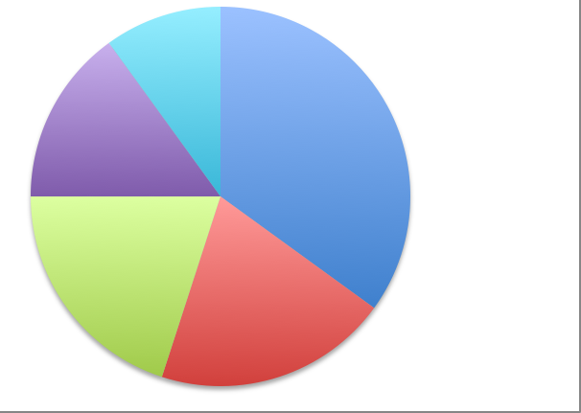
Test/Projects
35%
Classwork
20%
Quizzes/Labs
20%
Notebooks
15%
HW
10%

Responsibilities

If you are absent from class, regardless of the reason…..
- It is your responsibility to check the homework board/website to see what assignments you missed and what is due.
- It is your responsibility to make up missed work and hand in what you owe in a timely fashion.
- It is your responsibility to collect any missed handouts that were placed in the “While I Was Out” bin.

Class Conduct

Our class adheres to 5 basic conduct policies:

- Be courteous and respectful to others.
- Raise your hand and wait for permission to speak.
- Be prepared for class.
- Stay in your seat unless you have permission to do otherwise.
- Follow directions the first time they are given.

Policies

All HMS policies will be enforced in class, as outlined in the student handbook (front of student planner) and Comet Code of Conduct. A few reminders and policies that are specific to our class:

- Cell Phones/ iPods/ PSPs/ any electronic device – I don’t want to see or hear them!
- Hats – Not permitted in school. All hats that are brought onto school property must be stored in the students’ lockers. Any hats that are visible (on the head or carried) will be confiscated and returned upon the completion of an afterschool detention.
- Lateness – Will not be tolerated. All students must be in the classroom when the bell rings to be considered on time. Lateness to class without a pass will result in an afterschool or lunch detention.
- Plagiarism – Submitting any work that is not in your own words is considered to be plagiarism. Copying homework, cheating on a test, and copying and pasting directly from the internet or a publication are acts that constitute this offense. Any student who has been found to participate in any capacity in these activities will receive a zero on the assignment in question and a parent phone call. Subsequent offenses will follow the Comet Code of Conduct guidelines and will be brought to the attention of the assigned Vice Principal.

Communication

Please feel free to communicate any issues with me privately. If you are having a bad day, it helps if you let me know at the start of class. If you are having difficulty in class, I am here to help you, and can meet with you afterschool to help you as necessary. I can be contacted in the school during the day, in my classroom afterschool or via email at t.harrington@hackensackschools.org

Thank you in advance for your enthusiasm and cooperation! I look forward to an exciting year of learning with you!

Class Expectancy Contract

If you have thoroughly read the document and agree to the terms, please sign and return to Mr. Harrington. If you have any issues with the contract, please see me on an individual basis.
Student

I have thoroughly read and understand the class requirements and expectations of Mr. Harrington’s 7th grade Life Science class.

Print student name: ________________________________________

Student signature: _________________________________________

Date: _________________________________________

Parent/Guardian

Please complete the following after discussing the class requirements and expectations with your student:

Print parent/guardian name: _________________________________

Parent/guardian signature: __________________________________

Relation to student: ___________________ Date: _______________

Daytime phone: (___) ____-_____ Evening phone: (___) ____-_____

Email address: ______________________ @ _____________________

Please mark the appropriate boxes: | Yes, my student has access to  a computer at home. | No, my student does not have  access to a computer at home.
Please mark the appropriate boxes: | Yes, my student has internet  access at home. | No, my student does not have  internet access at home.
Please mark the appropriate boxes: | I would like to receive email  notifications of upcoming science  tests, projects and other special  announcements. | I would not like to receive any email  notifications.

