Welcome to
My Classroom!
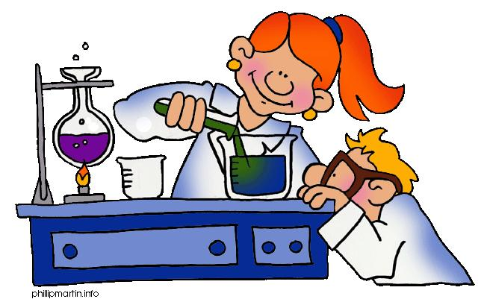
Mrs. Dietz-Nemec

My Educational Background:
- Currently in my 16th year of teaching in Hackensack
- Taught all major academic subjects in either the Resource Room or Inclusion settings
- Currently teaching grade 6 Science and grade 6 Core Plus More
- Have a BS Degree in Human Development & Family Relations from U. of Connecticut
- Have a Masters Degree in Special Education from Fordham U.

A Little Bit About Myself:
- Graduate of Hackensack High School (Go Comets! ☺)
- Married with two daughters and have an awesome dog!
- Hobbies include: walking, watching sports and home improvement shows, crafting (when I find the time)

Mrs. Dietz-Nemec * Grade 6 Science Class

What will students learn about in science this year?

Students will learn about several different topics this year:
- What is Science?/Scientific Method
- Unit 1: Variables*
- Unit 2: Weather & Water*
- Unit 3: Earth Science (Earth’s Interior Processes)*
- Unit 4: Planetary Science* (*See other sheet for more detailed information.)
* Students will also conduct many experiments to help them better understand the concepts being studied in class.

How will students be graded?

A student’s marking period grade will be based on his/her performance in many areas:

- Class participation/effort
25%
- Classwork/lab assignments
- Quizzes 25%
- Tests/Project work 40%
- Homework assignments 10%

*Behavior: (Please note that any modifications/accommodations stated in IEP will be carefully followed.)

What is Mrs. Dietz-Nemec’s homework policy?

Students will not have homework every night in science because some labs require a few days to complete. However, when homework is assigned, a due date will be given (usually the next day unless it is a paper/project). If a student does not complete homework by the due date, the student will be expected to stay at lunch recess or after school to complete the assignment (unless other arrangements are made with the parent/guardian ahead of time.)

You can look for homework assignments and more on my teacher website.

Can students come for extra help after school?

The answer is “YES!” Mrs. Dietz-Nemec is usually available after school most days of the week until 3:30 p.m. Students can always make an appointment with me in advance as well!

If you need to contact me, please feel free to call the Middle School office (grade 5/6 wing #) at 201-646-8170 or
the main Middle School Office (grade 7/8 wing #) at 201-646-8172
My school email: e.dietz@hackensackschools.org

SIXTH GRADE SCIENCE CURRICULUM
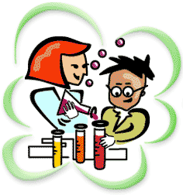

We are using FOSS KITS!!!

Some questions this course will investigate are:

Unit 1-Variables:
1. What is a variable and how is it used in a controlled environment versus a non-controlled environment?
2. Can the motion of an object be described by its position, direction, motion, or speed?
3. How can motion be measured and represented on a graph?
4. How can one design and conduct a scientific investigation to answer questions?
5. How is a system a set of related objects that can be studied in isolation?
6. How are time and volume measured?

Unit 2- Weather and Water:
1. Why does weather matter?
2. How and why is water essential to my life?
3. How does the water cycle affect the Earth’s atmosphere?
4. How are density and convection used as methods of energy transfer?
5. What is the relationship between changing air pressure and the wind?
6. How does the shape of Earth and its relationship with the Sun shape the atmosphere around us?

Unit 3- Earth’s Interior Processes:
1. How do geologists learn about Earth’s inner structure?
2. Identify the characteristics of Earth’s crust, mantle, and core.
3. What was Alfred Wegener’s hypothesis about the continents?
4. What evidence did Wegener use to support his hypothesis?
5. Why did other scientists of Wegener’s time reject his hypothesis?
6. What evidence was used to support sea-floor spreading?
7. What steps are involved in the cycle of sea-floor spreading and subduction?

Unit 4- Planetary Science:
1. How do the Earth, Moon, and Sun affect each other?
2. How did the Moon form and what are the main phases it goes through?
3. How can we make inferences and predictions as to the formation of the celestial bodies using simulated events?
4. How will using photographs help us to interpret features and predict positions of the Earth, Moon, and Sun?
5. How can we make models by using photographs and imagery that is not drawn to scale?

* One week of outdoor education or sixth grade camp*

F OSS
(Full Option Science System)
_____________________________________________


- The Full Option Science System comes from a philosophy of learning at the Lawrence Hall of Science, which has guided the development of successful science curricula for more than 25 years.

- The major goal is to engage students in active-learning (hands-on) science as much as possible.

- The system’s design includes thematic kits. Each kit covers a particular science concept. There are multiple kits per grade level.

- Kits include: 1. materials for experiments
2. comprehension and assessment performance tasks
3. comprehension and assessment worksheets
4. Science stories that relate to the concept being investigated
at that particular time

- Each kit is broken down into multiple investigations. Each investigation builds upon the next for a more complete understanding of the specific science topic being addressed.

FOSS WEBSITE
Please check out www.fossweb.com for so much great information and interactive games about the FOSS units studied in grade 6.

Mrs. Dietz-Nemec’s Grading System

(Classwork, Homework, Tests, Quizzes, Papers, & Projects)

Check System | Letter  Grade | Number  Equivalent | Expectation(s)
++  + | A+  A | 100  95 | Work is completed on time and is done well. All questions/tasks are attempted and answered to the best of the student’s ability. Answers reflect a very good understanding of the concept being taught at that particular time. Very neat.
 | B | 85 | Work is completed on time, however, one or two of the questions/tasks have not been completed properly. The work that has been completed shows a good understanding of the concept being taught at that particular time/May have some minor errors. Neat.
- | C | 75 | Work may be handed in on time, however, several questions/tasks have not been completed. Answers reflect an understanding of the concept being taught at that particular time to a satisfactory degree/May have errors that affect the understanding of the concept being taught at that particular time.  OR  Student’s work shows a satisfactory understanding of the concept being taught at that particular time, however, the work was handed in a day late.
- - | D | 65 | Work may be handed in on time, however, student appears to have significant difficulty with understanding of the concept being taught at that particular time.  OR  Student’s work shows a satisfactory understanding of the concept being taught at that particular time, however, the work was handed in two or more days late.
 | F | 64 or lower | Student appears to have great difficulty with understanding the concept being taught at that particular time.  OR  Lack of effort shown/50% or more of assignment incomplete
 |  | NO CREDIT | Work missing/Not handed in at all

