Name: _______________________________ Period____________________ Due date: _____________
Directions:
Students must create a comic strip according to the medical emergency they received on their index card.

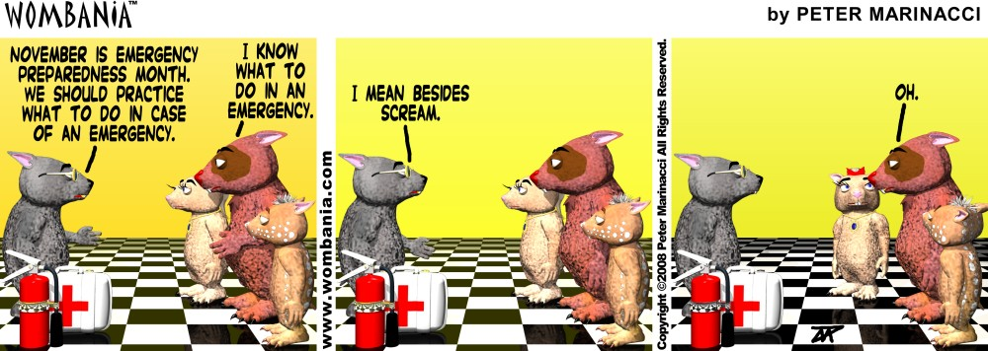

Checks | Comments | Grade | Actual grade | Comic strip quality
V++ | Outstanding comic strip | A+ |  | -Has the main idea  -Includes steps to follow in case of emergency  -includes what the terms mean according to medical emergency  -color  -pictures drawn or from magazine  -Explains the medical emergency
V+ | Satisfactory comic strip | A |  | -Student is missing one of below:  Has the main idea  -Includes steps to follow in case of emergency  -includes what the terms mean according to medical emergency  -color  -pictures drawn or from magazine  -Explains the medical emergency
V | Satisfactory comic strip but needs some work | B-B+ |  | Student is missing two of below:  -Has the main idea  -Includes steps to follow in case of emergency  -includes what the terms mean according to medical emergency  -color  -pictures drawn or from magazine  -Explains the medical emergency
V- | Comic strip Passed | C-C+ |  | Student is missing three of below:  -Has the main idea  -Includes steps to follow in case of emergency  -includes what the terms mean according to medical emergency  -color  -pictures drawn or from magazine  -Explains the medical emergency
V-- | No effort | D-F |  | Student missing 4 of below:  -Has the main idea  -Includes steps to follow in case of emergency  -includes what the terms mean according to medical emergency  -color  -pictures drawn or from magazine  -Explains the medical emergency
