Contents of the Science Fair Board
Directions: You need to have the following on your science fair display board.

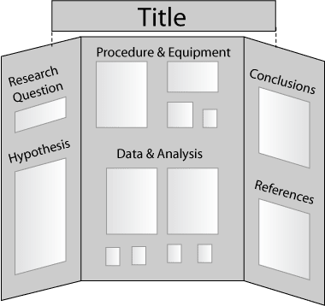

Title: Name of the experiment.

Research Question: What question are you trying to answer?

Hypothesis: This is what you think will happen before you start your
experiment.

Materials/Equipment: What items do you need to perform your experiment?

Procedure: These are the steps you follow to test your
problem.

Results(Data & Analysis): What happened? (Use tables and/or graphs to show your information along with a description.)

Conclusion: What is the answer to the question in your problem? How
do you explain your results?

References (if available): What books or resources did you use to further investigate your topic?

