Integers and Rational Numbers

SECTION A Family Letter: Integers
Dear Family,
Vocabulary
These are the math words we are learning:
absolute value the distance a number is from zero on a number line
integers the set of whole numbers and their opposites
opposites (additive inverse) numbers that are the same distance from zero on a number line
The student will be learning about integers and how these numbers relate to the coordinate plane. The set of integers includes the set of whole numbers (0, 1, 2, 3, ...) and their opposites (−1, −2, −3, ...).
Number lines will be used to introduce the concept of “opposite” numbers. The opposite of a number is the same distance from 0 on a number line as the given number. In mathematics, this is called absolute value. Absolute value is designated by the symbol | |. Absolute value is always positive because it denotes distance from zero, and distance cannot be negative.
|7| = 7 |−7| = 7
The student will learn how to add, subtract, multiply, and divide integers by following a few very important, yet simple, guidelines.
To subtract integers, change the subtraction sign to an addition sign and then add the opposite of what is shown. Then use the guidelines for adding integers.
Guidelines for Adding Integers
If the signs are the same, find the sum of the absolute values of the integers and give that sum the same sign of the integers in the problem.  Find the sum. −5 + −7  Think: Find the sum of 5  and 7. The signs are the same so give the sum the sign of the integers.  −5 + −7 = −12 | If the signs are different,  find the difference of the absolute values. Use the  sign of the integer with  the greater absolute  value.  Find the sum. −1 + 8  Think: Find the  difference between 1  and 8. Because 8 > 1,  use the sign of 8.  −1 + 8 = 7
Subtract.
A. 8 − 3
8 + (−3) = 5 Add the opposite of 3. Since 8 > 3, use
the sign of 8.
B. −5 − 4
−5 + (−4) = −9 Add the opposite of 4. The signs are the
same, so use the sign of the integers.
Integers and Rational Numbers

SECTION A Family Letter: Integers continued

To multiply and divide integers, the student will use the same process for multiplying and dividing whole numbers, except that he or she must determine the sign of the product
or quotient.
• If the integers have the same sign, the product or the quotient will ALWAYS be positive. −5(−6) = 30
• If the integers have different signs, the product or quotient will ALWAYS be negative. −5(6) = −30
The student will practice solving equations containing integers. such as y − (−4) = −9. To solve for y, you must get the variable by itself on one side of the equation. This is called isolating the variable, and it involves using inverse operations on both sides of the equation. Remember that inverse operations “undo” one another.
Solve each equation.
A. y − (−4) = −9
y − (−4) = −9 (−4) is subtracted from y.
+ (−4) = + (−4) To undo the subtraction and get y
by itself, add −4 to both sides of
y = −13 the equation.
B. −184 = 8n
184 = 8n 8 is multiplied by n.
=
To undo the multiplication and get n by itself, divide both sides of the equation by 8.
−23 = n

Continue to practice using integers with the student. He or she will use these skills throughout all aspects of mathematics.
Sincerely,
Integers and Rational Numbers

SECTION A At-Home Practice: Integers
Graph each integer and its opposite on a number line.
1. 3 2. 5 3. −1 4. −6

Find each sum.
5. 9 + (−14) 6. −71 + (−63) 7. 25 + (−47)

Find each difference.
8. −42 − (13) 9. −8 − (−7) 10. 9 − 31

Find each product.
11. −8 • 7 12. −4 • (−3) 13. −7 • −3 • 2

Find each quotient.
14. 81 ÷ (−9) 15. −25 ÷ 5 16. −42 ÷ (−6)

Solve. Check your answer.
17. m + 8 = 4 18. j = 9 19. −4 = c − 3 20. 6d = −24

Answers: 14. Points should be placed on 3, 3, 5, 5, 1, 1, 6, 6. 5. 5 6. 134 7. 22 8. 55 9. 1 10. 22
11. 56 12. 12 13. 42 14. 9 15. 5 16. 7 17. m  4 18. j  54 19. c = 1 20. d = 4
Integers and Rational Numbers

Family Fun: Integer Race
Materials
2 game pieces
Number cube

Play in teams of two. Place your marker on the first space and take turns
rolling a number cube. Substitute the number you rolled for the variable in
the problem and solve. If the answer is positive, move forward that number
of spaces. If the answer is negative, either move back that number of spaces or
return to start if that’s as far back as you can move. If the answer is zero,
stay in that space and lose your turn. First player to the end wins!

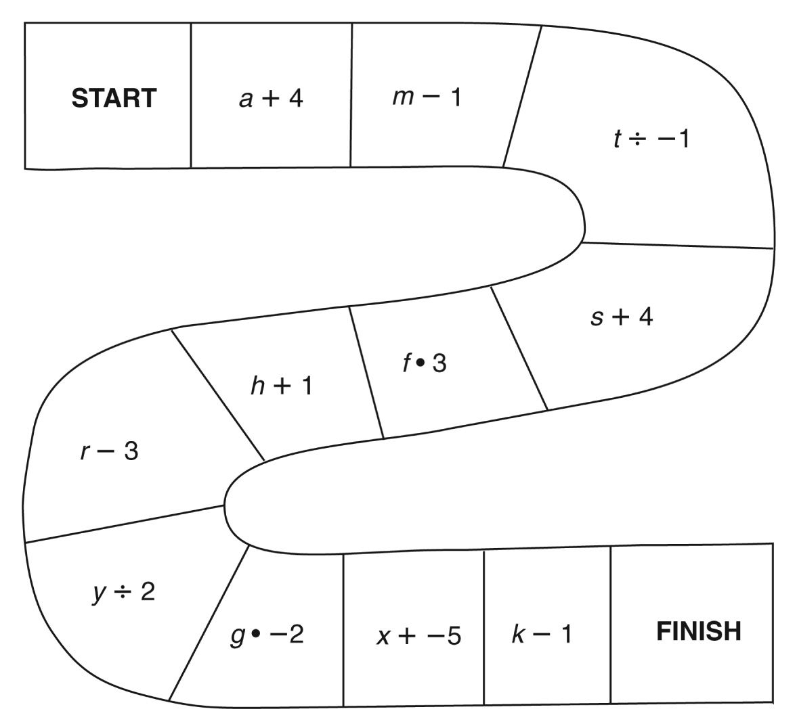

Integers and Rational Numbers

SECTION B Family Letter: Rational Numbers
Vocabulary
These are the math words we are learning:
rational number a number that can be written as a fraction, with integers for its numerator and denominator
repeating decimal a decimal that repeats a pattern forever
terminating decimal a decimal that comes to an end
Dear Family,
The student will be learning about rational numbers. The set
of rational numbers includes whole numbers, integers, fractions, and some decimals. Since fractions are such an integral part of rational numbers, the student needs to know how to find equivalent fractions so that they will be able to compare rational numbers. He or she can create equivalent fractions by multiplying or dividing both the numerator and the denominator of a given fraction by the same number.
Find two fractions equivalent to the fraction .
Multiply the numerator and the denominator by 2.
Divide the numerator and the denominator by 5.
To determine which rational number is greater, the student may need to write equivalent fractions by finding common denominators and comparing the numerators.
The student will also learn to convert between decimals and fractions. To convert a fraction to a decimal, the student will divide the numerator by the denominator. In some cases, the student might be asked to round this answer to a specified place value.
To convert a decimal to a fraction, the student will need to about place value. The value of the denominator is determined by where the decimal ends. For example in the decimal, 0.45, the “5” is in the hundredths place, so the fractional form of this number is .
The student will then reduce this fraction to simplest form by dividing both the numerator and denominator by the greatest common factor, in this case 5. So,

Integers and Rational Numbers

SECTION B Family Letter: Rational Numbers continued

The student will also write mixed numbers and improper fractions as decimals.
Practice converting between decimals and fractions and converting between mixed numbers and improper fractions with the student.
Converting from an improper fraction to a mixed number and decimal. | Converting from a mixed number to a decimal.
Write as a mixed number.  Divide the numerator by the denominator.  Write as a decimal.  or | Write as a decimal.  I will be the whole number part of the decimal.  Divide 4 by 9 to find the decimal part.
Use the quotient and the remainder to write the mixed number.
The decimal will repeat.
Sincerely,
Integers and Rational Numbers

SECTION B At-Home Practice: Rational Numbers
1. Place each number on the number line.
1.5 −0.75 2.25

Convert each improper fractions or mixed numbers to a decimal.
2. 3.

4. 5.

Convert each decimal to a fraction in simplest form.
6. 0.85 7. 3.2

8. 1.38 9. 3.07

Compare the fractions using < or >.
10. ___ 11. ___

12. ___ 13. ___

Place the following numbers in order from least to greatest.
18. 0.6, 0.603, 0.61 19. −3, 3.01, −2.5 20. 0.28, 2.08, −2.88

Answers: 1. Each point lies between two whole numbers. 2. 2.83 3. 4.75 4. 12 5. 3.9 6. 7.
8. 9. 10. < 11. < 12. > 13. > 18. 0.6, 0.603, 0.61 19. 3, 2.5, 3.01 20. 2.88, 0.28, 2.08
Integers and Rational Numbers

Family Fun: Circle Time
Directions
Find pairs of equivalent fractions and/or decimals in the hidden number
puzzle. Circle the pairs which appear in a vertical or horizontal line.
For each of the 10 pairs below, create a third equivalent fraction or decimal.
 | 0.9 | 0.05 | 2.2 |  |  | 1.25
 |  |  |  |  | 0.75
0.9 |  | 9 |  |  | 0.6
1.5 |  | 2 |  | 8 | 0.68
 |  |  |  |  |  | 3.2
9 |  | 0.2 |  |  | 0.75
List the 10 equivalent pairs. Create an additional equivalent fraction.
1. __________________________________________________________________
2. __________________________________________________________________
3. __________________________________________________________________
4. __________________________________________________________________
5. __________________________________________________________________
6. __________________________________________________________________
7. __________________________________________________________________
8. __________________________________________________________________
9. __________________________________________________________________
10. __________________________________________________________________

Answers: For 1–10 possible equivalent fractions follow answer.
1. 2. 3. 4. 5. 6.
7. 8. 9. 10.

