Proportional Relationships

SECTION A Family Letter: Ratios, Rates, and Proportions
Vocabulary
These are the math words we are learning:
cross product
for two ratios, the product of the first term in one ratio and the second term in the other ratio
equivalent ratios ratios that name the same comparison
proportion an equation that says two ratios are equivalent
rate a ratio that compares two quantities measured in different units
unit rate a rate whose denominator is 1 when written as a fraction
Dear Family,
The student will use ratios to learn about rates, and proportions. Recall, a ratio compares two quantities using division.
A ratio can be written in three different ways.
The local library has 15 part-time workers and three
full-time librarians. Write the ratio in all three forms.
Part-time workers to full-time librarians: 15:3 15 to 3
A ratio that compares two values with different units is called a rate. The unit rate compares a quantity to a unit of one.
Chas read 135 pages at a constant rate in 5 hours. How many pages did he read per hour? Write the unit rate in fraction and word form.
Compare pages and hours.
= Divide the numerator and denominator by 5.
Chas read 27 pages per hour.
An equation stating that two ratios are equivalent is called a proportion. You can determine whether two ratios are equivalent by writing the ratios in simplest form. If the ratios can be simplified to the same fraction, then the ratios are in proportion.
Determine whether the ratios and are proportional.
is already in simplest form.
= Simplify .
Since = , the ratios are proportional.
Proportional Relationships

SECTION A Family Letter: Ratios, Rates, and Proportions continued

The student will use cross products to solve proportions.
In the proportion = , where b ≠ 0 and d ≠ 0, the cross products, a • d and b • c, are equal.
Use cross products to solve the proportion.
=
3 • t = 15 • 5 The cross products are equal.
3t = 75 Multiply.
= Divide each side by 3.
t = 25
It is important to set up proportions correctly. Each ratio must compare corresponding quantities in the same order. Suppose a boat travels 16 miles in 4 hours and 8 miles in x hours at the same speed. Either of these proportions could represent this situation.
Trip 1 = Trip 2 =
The student will be able to apply these skills to real-life scenarios. Encourage the student to practice solving proportions.
Sincerely,
Proportional Relationships

SECTION A At-Home Practice: Ratios, Rates, and Proportions
Find the unit rates and write them in both fraction and word form.
1. Rachel drives 180 miles in 3 hours. 2. A store sells 12 drinks for $3.60.

3. 150 people travel in 3 buses 4. 250 cookies in 10 packages

Determine whether the ratios are proportional.
5. , 6. ,

7. ,

Use cross products to solve each proportion.
8. = 9. =

10. = 11. =

12. = 13. =

Answers: 1. ; Rachel drives 60 miles in 1 hour. 2. ; A store sells 1 drink for $0.30. 3. ; 50 people travel on one bus. 4. ; A package has 25 cookies. 5. yes; = 6. yes; = 7. no; ≠ 8. x = 8 9. m = 20 10. t = 18 11. h = 7 12. f = 6 13. j = 21
Proportional Relationships

Family Fun: Go Fish!
Directions
• Cut out the cards, shuffle, and give each player 3 cards. First determine
if you have a match. A proportion and its solution are considered a
match.
• If you do not have a matched pair, ask for a card from your opponent's
hand. If your opponent has the card you need, he or she must give you
that card. If your opponent does not have the card that you requested,
then you fish from the rest of the deck.
• You can use the bonus card only for a proportion, not the solution. To use
the bonus card, you must create a proportion and ask for the solution card.
• The winner is the first player to get 3 matches.

= | 7 | = | 4 | =
21 | = | 12 | = | 3
= | 6 | = | 15 | =
45 | = | 2 | = | 8
= | 12 | = | 14 | Bonus

Proportional Relationships

SECTION B Family Letter: Proportions in Geometry
Vocabulary
These are the math words we are learning:
corresponding angles the angles that are in the same relative position in two similar figures
corresponding sides the sides that are in the same relative position in two similar figures
indirect measurement a method of using proportions to find an unknown length or distance in similar figures
scale a ratio between two sets of measurements
scale drawing a proportional two-dimensional drawing of an object
scale factor a ratio that compares the size of a model to the actual size of the object
scale model a proportional three-dimensional model of an object
similar figures that have the same shape but not necessarily the same size
Dear Family,
The student will learn to use ratios to determine whether two figures are similar. Similar figures have the same shape but not necessarily the same size.
To determine whether two figures are similar, you must compare the measures of the corresponding angles and the ratios of the lengths of the corresponding sides.

Similar Figures
Two figures are similar if
• the measures of their corresponding angles are equal.
• the ratios of the lengths of their corresponding sides are proportional.
Tell whether the triangles are similar.
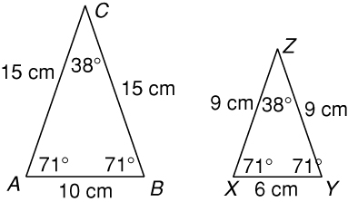
The corresponding angles of the figures have equal measures.
corresponds to
corresponds to
corresponds to
Since the measures of the corresponding angles are equal and the ratios of the corresponding sides are equivalent, the triangles are similar.
 | Write ratios using the corresponding sides.
 | Substitute the lengths of the sides.
= = | Simplify each ratio.
Proportional Relationships

SECTION B Family Letter: Proportions in Geometry continued

The student will use the properties of similar figures to find the measure of unknown lengths or unknown distances by setting up proportions to find the missing value. This form of indirect measurement is applicable to many everyday situations.
Harry and Sally both have rectangular swimming pools that are similar to each other. How wide is the pool at Sally’s house?
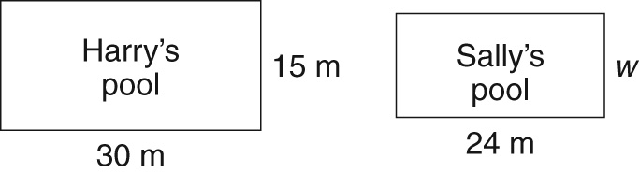
Let w = the width of Sally’s pool.
= | Write a proportion using corresponding sides.
30 • w = 24 • 15 Find the cross products.
30w = 360 Multiply.
= Divide each side by 30.
w = 12
Sally’s pool is 12 m wide.
Scale models and drawings are proportional representations of objects. The scale factor tells you how the dimensions of
a model or drawing are related to the dimensions of the
actual object. A scale factor is always the ratio of the
model’s dimensions to the actual object’s dimensions.
An architect’s model of a building is 18 inches tall.
The actual building is 360 inches tall. What is the
scale factor?
= = Write a ratio. Then simplify.
The scale factor is .
The concepts and skills learned in this section are applicable to many activities outside of the math classroom. Provide opportunities for the student to use the skills learned in this chapter in real-world applications.
Sincerely,

Proportional Relationships

SECTION B At-Home Practice: Proportions in Geometry
Tell whether the triangles are similar.

1. 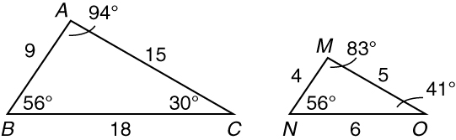

2. 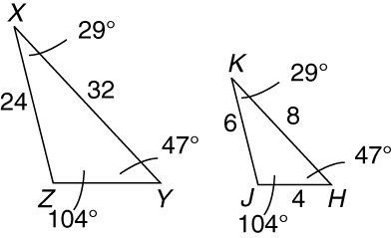

Tell whether the figures are similar.

3. 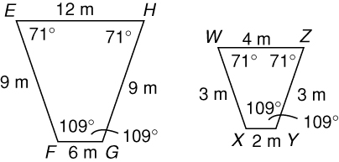

4. 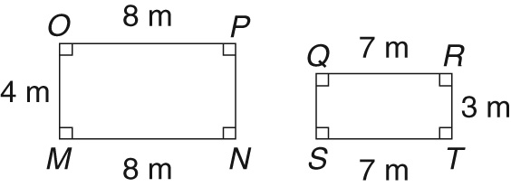

Find the unknown length in each pair of similar figures.

5. 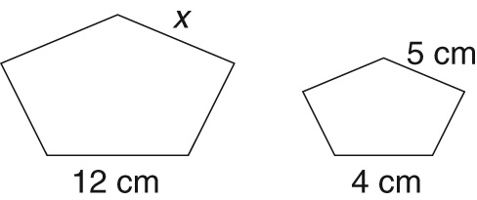

6. 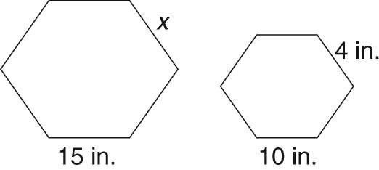

Identify the scale factor.
7.
 | Car | Model
length (in.) | 102 | 6

Scale Factor = ___________________________

Answers: 1. not similar 2. similar 3. similar 4. not similar 5. x = 15 cm 6. x = 6 in. 7.

Proportional Relationships

Family Fun: Scale It Down
The Washington Monument is the tallest all-masonry tower in the world.
It was designed by Robert Mills in 1848. When Mills died in 1855, George
P. Marsh took over the project.
Marsh suggested that the projected height of 600 feet be reduced
to the standard Egyptian proportions of ten times the base to the height.
The base of the monument is 55 feet wide.
What is the height? _____________________________________.
Finally, Marsh proposed that a pyramid cap of aluminum top this great monument. The project was completed in 1885.
Directions
• Make a scale drawing of the Washington monument in the space provided. Determine your scale factor and label your drawing.
• Use your drawing to create a scale model. Use a variety of materials
such as modeling clay, craft sticks, milk cartons, blocks, etc.
• Investigate other famous monuments or structures in order to create
another scale model.

Scale Drawing of the Washington Monument

Scale Factor ___________

Answer: 550 ft

