Hackensack Grades 5-8 Spanish Homework Policy

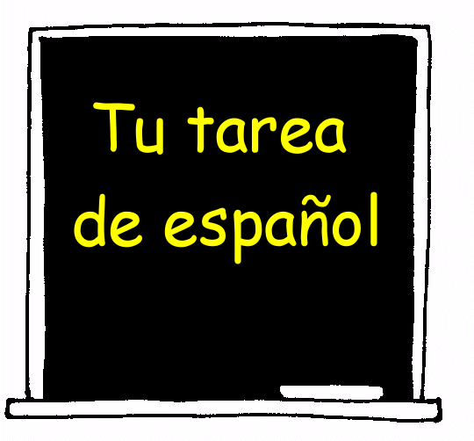

When given homework, students are expected to complete all homework assignments in a careful manner. If they do not understand how to complete an assignment they should refer to the notes that have been given in class for that particular lesson.

Homework will be collected and checked; if it is correctly completed the student will receive a check plus. Partially completed work will earn a check. If it is partially done and no work is shown student will receive a check minus. Any late homework receives check minus as a grade.

Homework will be posted each day on the board and it is the student’s responsibility to write the homework in the student planner. Homework will also be posted on teacher’s website. Go to www.hackensackschools.org/. You can find the teacher’s website by clicking the link “Teacher Webpages” on the left hand side of the page.

If the missing assignment is a result of an illness the student may submit the assignment the following class to receive full credit.

Students are expected to make-up all homework that is missed due to absences and/or extra-curricular activities. It is the student’s responsibility to make sure that home learning assignments are up to date.

Students are expected to come to class prepared with their Spanish textbook (grades 7 & 8), notebook, and pencil.

If a student loses his or her Spanish textbook please have the student see their Spanish teacher to inquire on the replacement cost.

