NorthandSouthbook.com

The goal of this mini-project is to select a key figure of the American Civil War and make a social-networking-style profile page for that individual, demonstrating a clear and thorough knowledge of their role during this period. You may choose from:

John C Calhoun Jefferson Davis Abraham Lincoln
Clara Barton Frederick Douglas Dred Scott
John Wilkes Booth Stephen Douglas Daniel Webster
Ulysses S Grant William Tecumseh Sherman John Brown
Stonewall Jackson Harriet Beecher Stowe Henry Clay
Robert E Lee Harriet Tubman

Your primary source is textbook Chapters 8 and 9. The internet may be used as a supplementary source.

Personal Information:

Students are to post their individual’s personal information and interests using evidence from the text, class lessons, and the internet. Include a photograph of the individual.

Groups:

Students are to choose at least two groups (or clubs) that their individual may be a part of based on their interest.

Photo Albums:

Students are to think about places their individual may have taken pictures and/or people they may have taken pictures with. Photo albums must reflect key events or themes of the war.
(For example, Frederick Douglas may post a photo album of the 54th Massachusetts unit.)

Upcoming Events:

Students are to think about upcoming events that their individual may attend.

The Wall:

Students are to depict three other persons that might comment on their individual’s profile page. The images and comments of the other persons should be appropriate to their individual as outlined in the text.
(For example, Grant may write on Sherman’s wall, “Way to light it up in Atlanta last night!”)

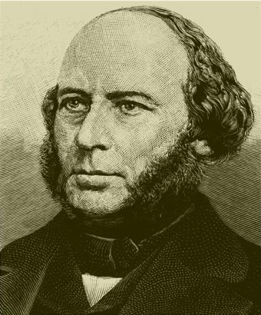

Birthday:
Marital Status:
Current Location:
Political Views:

Personal Information
John Ericsson
E-mail address: ____________________________
Friends

Screen name: ___________________________

Activities: ________________________________
________________________________

Favorite Music: ____________________________
Favorite Books: ____________________________
Favorite Quote: ____________________________

Groups: ___________________ Wall: Write on _______________________Wall!
_________________________

_________________________ ____________________ writes...
Photo Albums
Showing 2 of ____________ albums

___________________
Created ____________
___________________

___________________
Created ____________
___________________

____________________ writes…
_

Upcoming Events
__________________

Where: ____________

When: ___________

___________________ writes…

Individual’s Name:

Reason why you picked this person:

- Explain the significance of the email address/screen name created.

- Explain the significance of the activities listed for your person.

- Explain the significance of the “favorites” listed for your person.

- Explain the significance of the other individuals, images, and posts added to your person’s wall.

- What person from any other era in History may your person friend? Explain.

Appearance | identical to the template, may have added details that enhance the overall project; student went above and beyond to represent their individual to the fullest  4 | nearly identical to the template; student adequately represented their individual  3 | missing minor elements;  student did not adequately represented their individual  2 | missing key elements;  final product does not represent the task  1
Statements of Significance –  Evidence  and  Analysis  (Questions 1-5) | thoughtful and accurate evidence, thorough explanation and analysis;  clearly represents key aspects of their individual  10 | accurate evidence, explanation and analysis;  accurately represents key aspects of their individual  8 | some evidence, explanation and analysis;  inadequate or inaccurate representation of their individual  6 | little or no evidence, explanation and analysis  2
Adherence to the facts and events of the Civil War | thorough understanding of their individual and other significant elements of the war  6 | adequate understanding of their individual and other significant elements of the war  4 | inadequate understanding of their individual and other significant elements of the war  2 | little or no understanding of their individual and other significant elements of the war  1
Neatness, Spelling, & Creativity | high level of creativity;  neat, accurate spelling;  shows pride in work by paying attention to details  5 | adequate level creativity;  neat, mostly accurate spelling; concerned with details  4 | little attention to creativity, neatness, and spelling  3 | no evidence of thoughtful attention to neatness, creativity, or spelling  1
Total: ________________________/25

Comments:
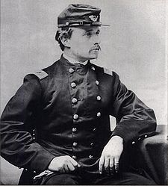
Colonel Robert Gould Shaw
Forward 54th, Forward!
Birthday: October 10, 1837
Gender: Male
Marital Status: Married
Current Location: Morris Island, South Carolina
Political Views: All men are created EQUAL!

Personal Information

Email Address: RGShaw54@gmail.com
AIM Screenname: RGShaw54
Activities: Horseback riding, marksmanship, military strategies

Favorite Music: Justice for all by Metallica
Favorite Books: Art of War by Sun Tzu, All Men Are Brothers by Mahatma Ghandi
Favorite Quotes: “…all persons held as slaves within any State, or designated part of a State, the people whereof shall then be in rebellion against the United States, shall be then, thenceforward, and forever free;…” Abraham Lincoln

Wall
Write on Robert Shaw’s wall!

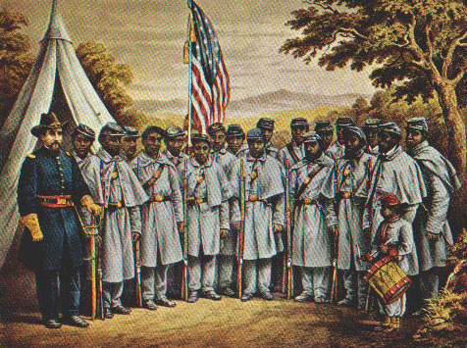
Massachusetts Governor John Andrew
You have been recruited to raise and command one of the 1st regiments of freed men in the Union Army, the 54th Massachusetts Infantry. Make us proud!
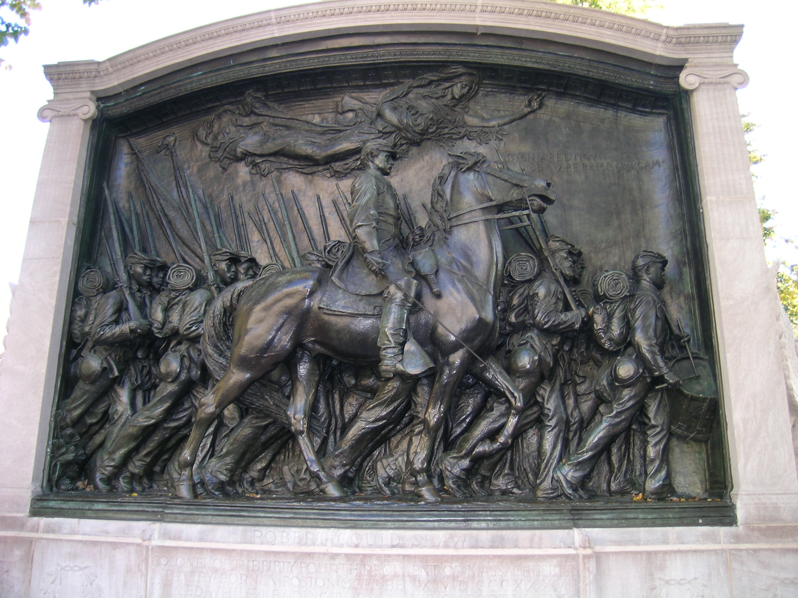 Frank Shaw
We would not have his body removed from where it lies surrounded by his brave and devoted soldiers....We can imagine no holier place than that in which he lies, among his brave and devoted followers, nor wish for him better company.– what a body-guard he has!"

Photo Albums:
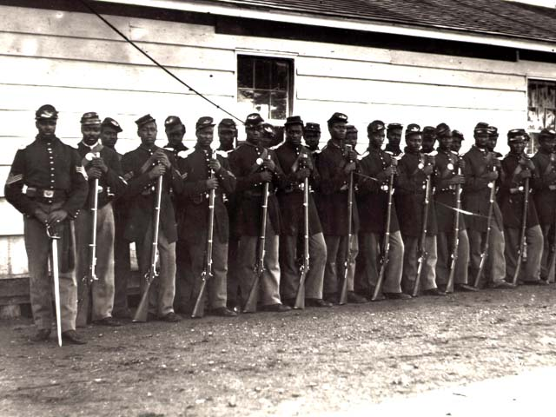
54th Mass. Ready for battle!
Created May 28th, 1863

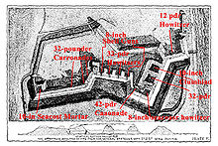
Battle at Fort Wagner!
Created July 18th, 1863

