Osmosis Practice Problems
MULTIPLE CHOICE. Choose the one alternative that best completes the statement or answers the question.

1) Inside one osmosis bag, A, is a 50% glucose solution and side bag B is a 20% glucose solution. Both bags are put into beakers containing 100% water.
A) Bag A will gain weight.
B) Bag B will gain weight.
C) Both bags will gain weight.
D) Both bags will loose weight.
E) Both bags will remain the same.

2) A 0.9% NaCl solution is isotonic to red blood cells. Which of these describes the results if red blood cells are placed into a 9% solution of NaCl?
A) They will burst.
B) They will shrink.
C) Nothing will happen.
D) They will expand but not burst.
E) None of the above.

3) The U-shaped tube in the figure below is divided by a membrane that is impermeable to starch but permeable to water. Which of the following will occur?
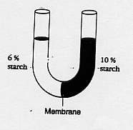
A) Water will move from the right to the left.
B) Water will move from the left to the right.
C) Starch will move from the right to the left.
D) Starch will move from the left to the right.
E) Nothing will happen. The membrane blocks the passage of all the molecules.

4) Wallway is a new general herbicide for aquatic plants. Its main ingredient is a marine salt solution. It is effective against freshwater but not saltwater plants. It works by breaking down the cell walls of the plants. The freshwater plants dies because their cells
A) swell and burst.
B) shrink and cease to function.
C) remain the same size but malfunction.
D) are crushed by the weight of the plant.

5) A red blood cells has a salt concentration of 0.9%. What will happen if it is placed into a 0.8% salt solution? The red blood cell will
A) shrink if its membrane is permeable to both the salt and the water.
B) shrink if its membrane is impermeable to the salt and permeable to the water.
C) maintain its shape, ie nothing will happen.
D) swell and probably burst because its membrane is impermeable to salt and permeable to water.
E) swell and probably burst because its membrane is impermeable to water and permeable to salt.

6) Two beakers (below) are connected by a tube partioned by a membrane permeable to water but not to protein. Which one of the following statements best describes what will happen to this system?

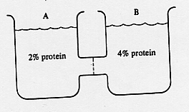
A) Water will only move from A to B.
B) Water will only move from B to A.
C) Water will move equally in both directions so that there will be no net change in the system.
D) Water will move in both directions, but the net flow will be from A to B.
E) Water will move in both directions, but the net flow will be from B to A.

7) The solutions in the 4 artificial cells diagrammed below are separated from each other by stationary, differentially permeable membranes. The membranes are permeable only to the water.

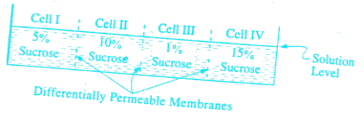
As the experiment progresses, which of the following is true about the amount of sucrose in the cells? It

A) increases in every cell.
B) increases in II, but not in I, II or IV.
C) decreases in every cell.
D) decreases in I and III but not in II and IV.
E) does not change in any cell.

1)
Answer:
C

2)
Answer:
B

3)
Answer:
B

4)
Answer:
B

5)
Answer:
D

6)
Answer:
D

7)
Answer:
E

