elements of create
*Appropriate self expression and discovery through Creative Arts and Technology Projects

Art and Technology Special

Hackensack Middle School
*Heritage Research- Authoring of Self – Invent a Game about your Culture

*Problem solving and Team Building Activities

*Cross curriculum connections/ Social Studies, Science and Math extensions

*Opportunities for appropriate self expression and positive social skills

*Literacy linked multicultural studies

*Web Based Tech. Connections

*Community connections and mentors (guest speakers and local resources)

*Citizenship, Responsibility, Character Building

*Career Explorations/ Education
(Exposure to vocations/ pathways in the working world)

project based hands on learning

*Year End Culminating Activity (Festival, Fair or “Open Studio”)

C.R.E.A.T.E. Studio

Date of publication
Ms. Jerilynn Clemente

B.A., Art Therapy
Trenton State College, NJ

M.P.S., Creative Arts Therapy
and Special Education
Pratt Institute, Brooklyn, NY

NJ and NY Teaching Certificates in Special Education and Art (K-12)

Registered Art Therapist (A.T.R.) with the American Art Therapy Association

C.R.E.A.T.E. Studio
Room 143- HMS

email: j.clemente@
hackensackschools.org


@HMSCREATESTUDIO



C. reative
R. esponses,
E. xpressive
A. rts &
T. echnology
E. ducation

"I hear and I forget. I see and I remember. I do and I understand." -Confucius

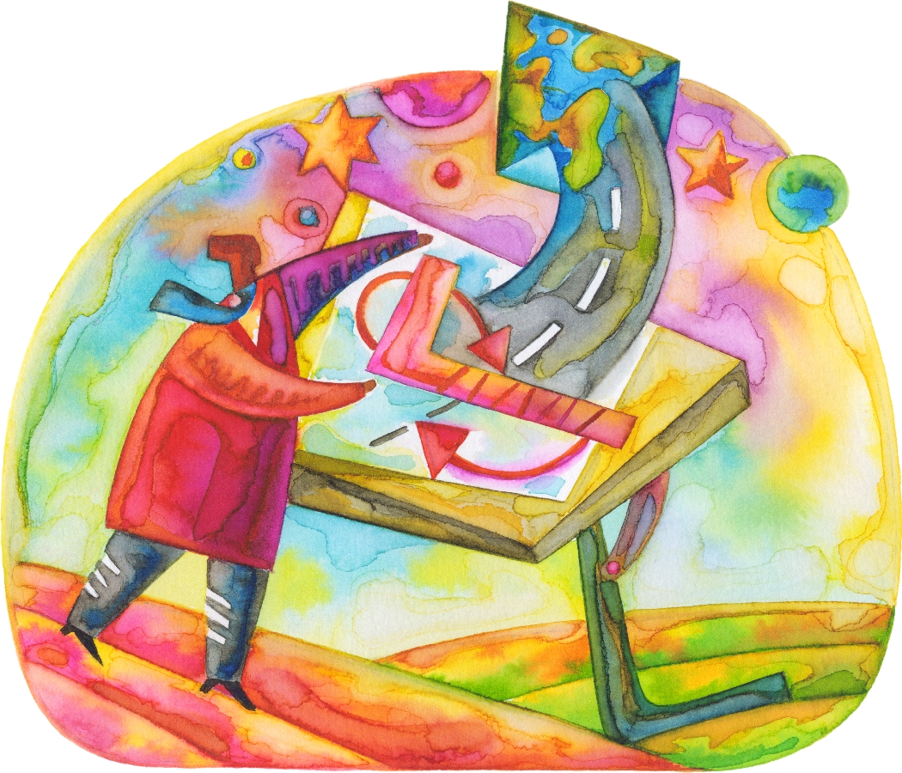

The CREATE STUDIO at Hackensack Middle School is an ART STUDIO based program that is infused with TECHNOLOGY components.

Based on the notion that “Learning is Doing”, the CREATE Studio will allow students to explore a variety of artistic and technological tools and materials through project- based, hands on experiences.

Students will use their prior knowledge and skills via cross curriculum connections. They will be able to utilize what they are learning in their core classes by applying these concepts and talents in their art and construction projects.

Students are faced with a particular task to solve using limited materials. They must collectively problem solve a unique and viable solution.

Students will have the opportunity to work in groups and become more familiar with responsibility and teamwork. The nature of the design and construction process requires respect and tolerance of others ideas and abilities. Projects include partnership learning activities, painted murals and team design challenges. CREATE projects will allow for an increase in self awareness and a better understanding of the how personal decisions impact one’s own and other’s lives. Both structured and unstructured learning within the studio foster communication and cooperation skills.

Students in the CREATE STUDIO also participate in school wide events by supporting clubs, groups and organizations. They design and create items for PBSIS, PTA events, Students council, and performing arts assemblies and showcases. These opportunities help foster a sense of school spirit and belonging within the HMS community.
In addition, plans are in progress to extend parts of the program out into the Hackensack community. We look forward to showcasing artworks in Main Street businesses and donating projects to local organizations and charities.

CREATE STUDIO students explore a variety of multi-cultural artistic endeavors ranging from the early 1800’s to modern day. The study of these expressive arts timelines allows students to become aware of positive outlets and mediums for their own self-expression. Students are exposed to a range of artistic styles and base their own work upon this study and research.

Part of CREATE STUDIO lessons involve student awareness about possible career opportunities and future job skills related to their projects. Students learn the important tasks of setting up and cleaning up their work areas in a safe and appropriate manner.
The physical layout of the CREATE STUDIO space and nature of the projects offer students a chance to stand and move around while working. Interactive and kinesthetic experiences are often motivating factors for the adolescent age group.
In terms of parental involvement, I respectfully request that you ask your children about the tools, materials, and procedures related to their projects. We welcome visitors! Please support and encourage their creative endeavors in all of the arts.

.
.
.
.

