Algebraic Reasoning

Practice A: Translating Words Into Math

Write as an algebraic expression.
1. the sum of m and 8 2. the product of 3 and n

3. 4 less than x 4. the quotient of a number and 12

5. 52 times a number 6. w less than 15

7. the sum of 13 and a number 8. the product of 5 and p, increased by 10

9. the sum of 15 divided by b and 6 10. 12 less than the amount y divided by 2

11. 26 increased by 12 times a number
12. the difference of 2 times a number and 6
13. the product of h and 3, increased by 20
14. 18 less than the product of a number and 4
15. take away 32 from the product of 6 and a number
16. Used video games cost $25 each. Write an algebraic
expression to find the cost of m video games.
17. Sal earned $740 for n weeks of work. Write an algebraic
expression for the amount he earned each week.
18. At the end of the 2004–2005 NBA season, Reggie Miller
was the all-time leader in 3-point field goals made.
He made n more field goals than Dale Ellis. Dale Ellis
made 1,719 3-pointers. Write an algebraic expression to
find the number of 3-pointers Reggie Miller made.
19. The $2 bill has Thomas Jefferson on the front of it.
Write an algebraic expression to find out how much money
v bills with Thomas Jefferson on them would be worth.

Practice C
1. 56 2. 30
3. 25 4. 82
5. 28 6. 73
7. 232 8. 102
9. 4 10. 5,000
11. 65 12. 191
13. 78 14. 23
15. 48 cubic inches
16. 32 seconds longer
Review for Mastery
1. 10 2. 13; 8
3. 6; 2 4. 12; 9; 21
5. 5; 15; 13 6. 4; 4; 20; 4; 24
7. 2 8. 20
9. 5 10. 13
11. 7 12. 11
13. 70 14. 25
15. 3
Challenge
1. n + 28; 36 − n; 8n; 128 ÷ n
2. n + 84; 108 − n; 8n; 1,152 ÷ n
3. n + 150; 162 − n; 26n; 936 ÷ n
4. n + 84; 112 − n; 7n; 1,372 ÷ n
5. n + 45; 69 − n; 4.75n; 684 ÷ n
6. n + 124; 372 − n; 2n; 30,752 ÷ n
Problem Solving
1. about 116 hours
2. 52; 1,508 hours 3. 2037
4. 144 miles 5. C
6. F 7. D
8. H
Reading Strategies
1. p and t 2. 8 + 4(6) − 2(2)
3. multiplication 4. 8 + 24 − 4
5. addition 6. 32 − 4
7. 28
Puzzles, Twisters & Teasers
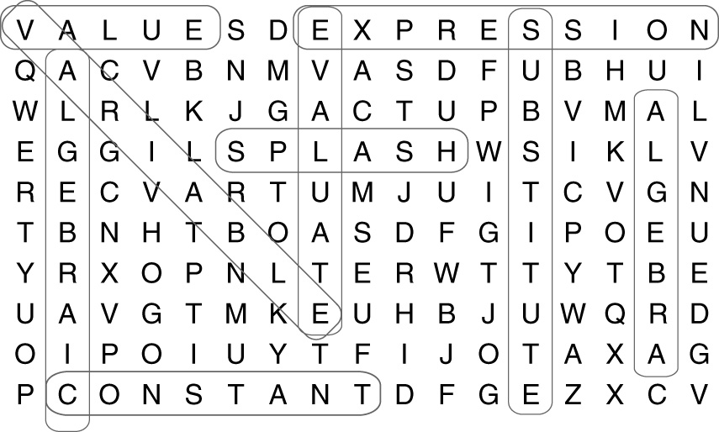
SPLASH
Answers for Lesson 4
Practice A
1. m + 8 2. 3n
3. x − 4 4. a ÷ 12
5. 52k 6. 15 − w
7. 13 + e 8. 5p + 10
9. 15 ÷ b + 6 10. y ÷ 2 − 12
11. 26 + 12s 12. 2a − 6
13. 3h + 20 14. 4n − 18
15. 6z − 32 16. 25m
17. 740 ÷ n 18. 1,719 + n
19. 2v
Practice B
1. 125 − n 2. z + 359
3. 35f 4. 100 ÷ w
5. 2r + 27 6. 15x − 12
7. 4e ÷ 12 8. 18 • 6 − y
9. m ÷ 64 + 48 10. 4t − 500
11. p ÷ 4 − 320 12. 13(60 − w)
13. 45 ÷ (c + 17) 14. 2(d + 600)
15. n ÷ 2 16. 4,160 ÷ x
17. 290a + 5b 18. 0.10m + 5
Practice C
1. 6n² 2. (6n)²
3. 4(r + 6,008)

