Integers and Rational Numbers

Practice B: Adding Integers
Use a number line to find each sum.
1. −1 + 5 2. 4 + (−6)

Find each sum.
3. −51 + (−9) 4. 27 + (−6) 5. 1 + (−30) 6. 15 + (−25)

7. 50 + (−7) 8. −19 + (−15) 9. (−23) + 9 10. −19 + (−21)

11. −17 + 11 12. 20 + (−8) 13. (−15) + (−7) 14. 12 + (−14)

Evaluate e + f for the given values.
15. e = 9, f = −24 16. e = −17, f = −7 17. e = 32, f = −19

18. e = −15, f = −15 19. e = −20, f = 20 20. e = −30, f = 12

21. The temperature rose 9 °F in 3 hours. If the starting temperature was −5 °F, what was the final temperature?

22. Matt is playing a game. He gains 7 points, loses 10 points, gains 2 points, and then loses 8 points. What is his final score?

Challenge
1. −12 < −11 < 6
2. −201 < −3 < −1
3. −6 < | −3 | < | −6 |
4. −7 < | 3 | < | −38 |
5. 4 > −4 > −40
6. | −18 | > 0 > −8
7. | −75 | > | 12 | > 7
8. 1 > −12 > −16
A N A B S O L U T E V A L U E
Problem Solving
1. −80
2. outside Jared’s house
3. −62,500; 34,100
4. −3 °C; −1 °C; 0 °C; 2 °C; 5 °C
5. C 6. F
7. A 8. J
Reading Strategies
1. the set of whole numbers and their opposites
2. −6 3. −10
4. 0 5. 8
6. 3 7. integer
8. not an integer
9. not an integer
10. integer
Puzzles; Twisters & Teasers
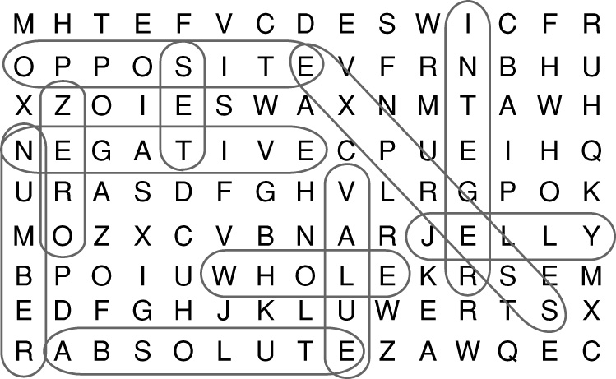
J E L L Y
Answers for Lesson 2
Practice A
1. 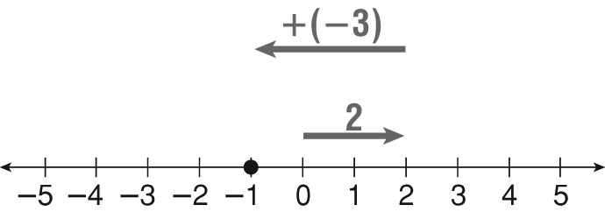
−1
2. 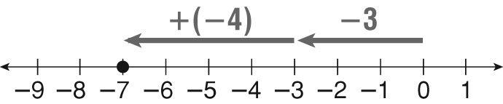
−7
3. −13 4. −1
5. −1 6. −3
7. 12 8. 4
9. 8 10. −16
11. −5 12. −10
13. 5 14. 4
15. 7 16. −10
17. 5 18. −1
19. 2 20. −5
21 . 11 °F 22. 3 yards
Practice B
1. 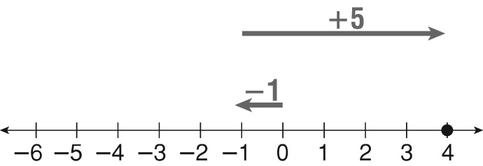
4
2. 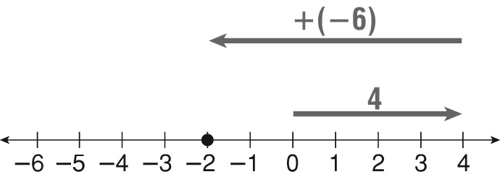
−2
3. −60 4. 21
5. −29 6. −10
7. 43 8. −34
9. −14 10. −40
11. −6 12. 12
13. −22 14. −2
15. −15 16. −24
17. 13 18. −30
19. 0 20. −18
21. 4 °F 22. −9 points
Practice C
1. 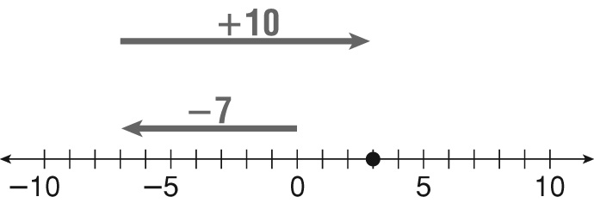
3
2. 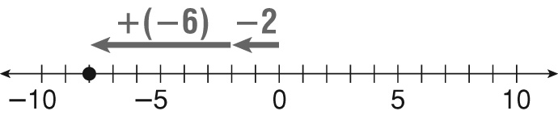
−8
3. −36 4. −23
5. 29 6. 70
7. 19 8. −94
9. −14 10. −96
11. 6 12. −2
13. −23 14. −4
15. 38 16. −80
17. −29 18. =
19. > 20. <
21. −1 °F
22. −6 points or a loss of 6 points
Review for Mastery
1. subtract 2. negative
3. add 4. negative
5. −13 6. 4
7. −5 8. −1
9. −4 10. 2
11. −5
Challenge
1. −13 2. −22
3. −22 4. −27
5. −2 6. −16
7. −19 8. −5
9. −18 10. >
11. = 12. >
13. > 14. <
15. > 16. <
17. < 18. <
19. Answers will vary.
20. Possible answer: chalk
21. Possible answer: bench
22. Answers will vary.
Problem Solving
1. 5 °F 2. −22 °F
3. $35 4. 535 ft
5. −97 ft 6. 17,500 ft
7. B 8. H
9. C 10. J
Reading Strategies
1. 0 2. to the right; 6
3. to the left; 4 4. 0
5. to the left; 5 6. to the left; 3
Puzzles, Twisters & Teasers
R: −9
S: 7
L: −19
H: −88
O: −6
E: −18
C: 39
W: 25
D: 13
A: −17
T: −16
N: 1
S H E W A N T E D
C O L D H A R D C A S H

