Proportional Relationships

Practice B: Using Similar Figures
ABC ~ DEF in each pair. Find the unknown measures.

1. 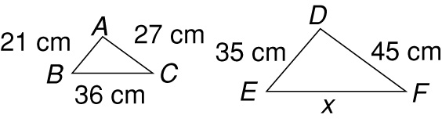

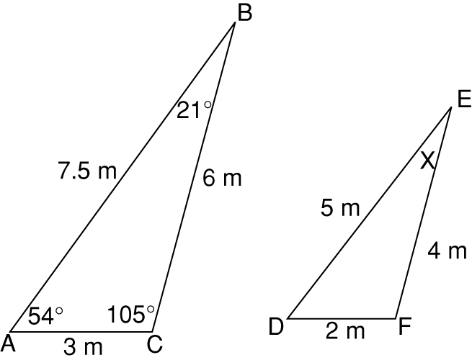
3.

5. The two rectangular picture frames at the right are similar. What is the height of the larger picture frame?

6. A palm tree casts a shadow that is 44 feet long. A 6-foot ladder casts a shadow that is 16 feet long. Estimate the height of the palm tree.

2. 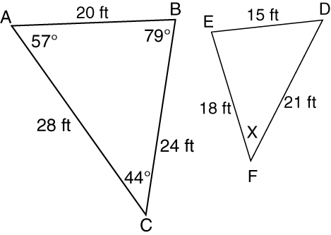
COMP

4. 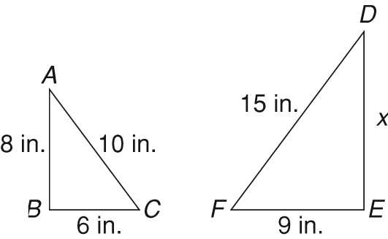

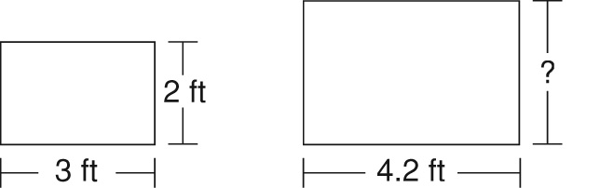
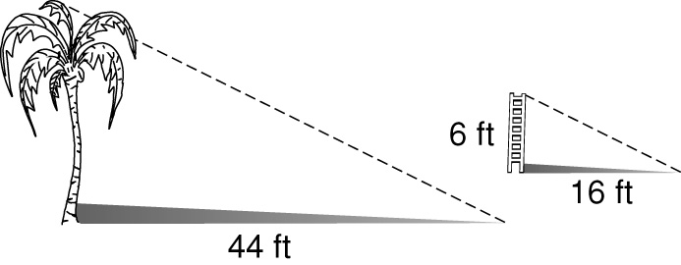

Challenge
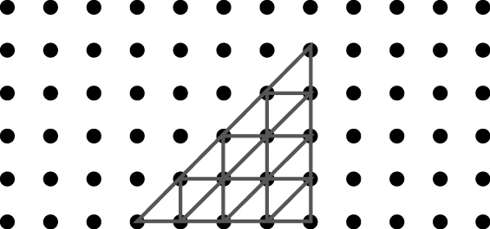
1.


2.


3.

4.


5. Drawings will vary. Possible drawing given.
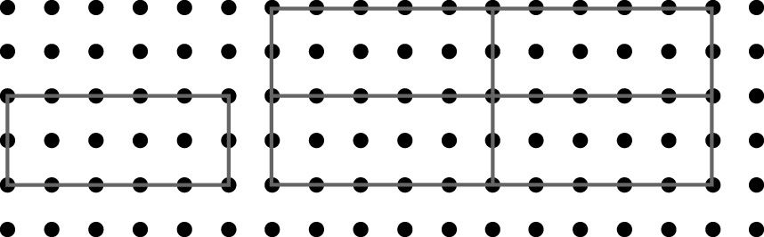
Problem Solving
1. The Dance Class
2. yes; 1:4
3. yes; 1:2
4. A 5. H
6. D 7. G
Reading Strategies
1. angle E 2. angle D
3. side EF 4. yes
5. no
Puzzles, Twisters & Teasers
Similar figures:
R and C; A and G; W and O;
Y and E; F and N
T U L I P S
Answers for Lesson 5
Practice A
1. Possible answers are given.
= ; x = 24 ft
2. = ; x = 8 cm
3. = ; x = 18 in.
4. = ; x = 9 m 5. 10.5 feet
6. 4 feet
Practice B
1. x = 60 cm 2. x = 44°
3. x = 21° 4. x = 12 in.
5. 2.8 feet 6. 16.5 feet

