Integers and Rational Numbers

Practice B: Subtracting Integers
Use a number line to find each difference.
1. −2 − 3 2. 5 − (−1)
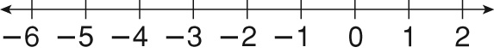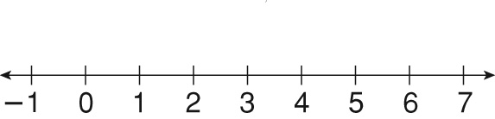
_______________________________________ _______________________________________
Find each difference.
3. −6 − 4 4. −7 − (−12) 5. 12 − 16 6. 5 − (−19)

7. −18 − (−18) 8. 23 − (−23) 9. −10 − (−9) 10. 29 − (−13)

11. 9 − 15 12. −12 − 14 13. 22 − (−8) 14. −16 − (−11)

Evaluate x − y for each set of values.
15. x = 14, y = −2 16. x = −11, y = 11 17. x = −8, y = −15

18. x = −9, y = −9 19. x = 9, y = −20 20. x = 20, y = 25

21. The high temperature one day was −1 °F. The low temperature was −5 °F. What was the difference between the high and low temperatures for the day?

22. The temperature changed from 5 °F at 6 p.m. to −2 °F at
midnight. How much did the temperature decrease?

Answers for Lesson 3
Practice A
1. 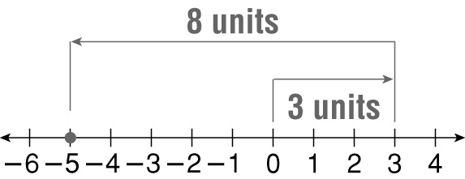
−5
2. 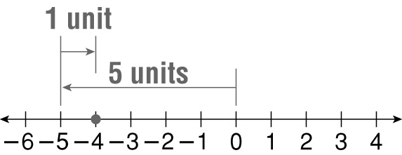
−4
3. −7 4. −5
5. 6 6. 9
7. −16 8. 0
9. 1 10. 12
11. 7 12. 16
13. −11 14. 4
15. 9 16. −8
17. 3 18. −2
19. 0 20. −10
21. 9 °F 22. 14 °F
Practice B
1. 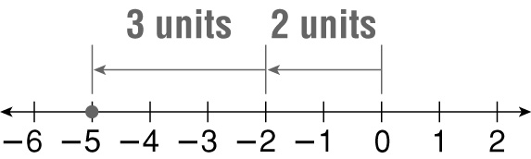
−5
2. 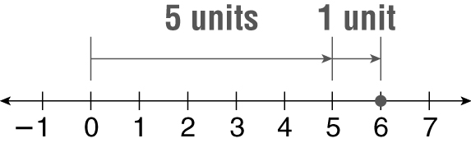
6
3. −10 4. 5
5. −4 6. 24
7. 0 8. 46
9. −1 10. 42
11. −6 12. −26
13. 30 14. −5
15. 16 16. −22
17. 7 18. 0
19. 29 20. −5
21. 4 °F 22. 7 °F
Practice C
1. 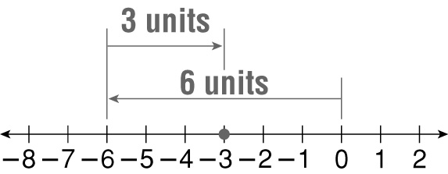
−3
2. 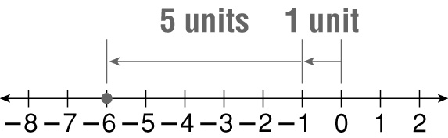
−6
3. −31 4. −12
5. −16 6. 38
7. 66 8. −74
9. 0 10. −52
11. −48 12. 10
13. −7 14. −12
15. 14 16. 0
17. −20 18. 25
19. −57 20. 144°F
21. −5 °F
Review for Mastery
1. a. 5; b. −1; c. 20
2. a. negative; b. 2; c. −2
3. a. positive; b. 8; c. 8
4. 40 5. −3
6. −26 7. 0
8. 31 9. −5

