Graphs

Practice B: The Coordinate Plane
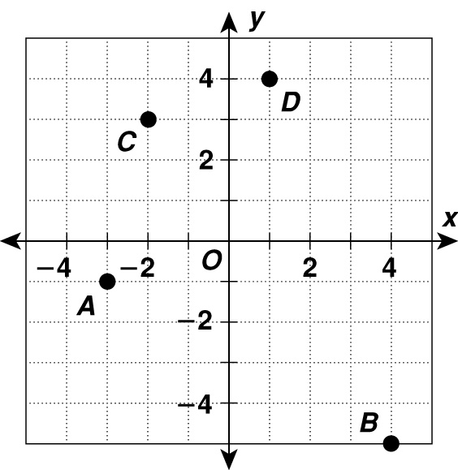
Identify the quadrant that contains each point.
1. A __________________
2. B __________________
3. C __________________
4. D __________________

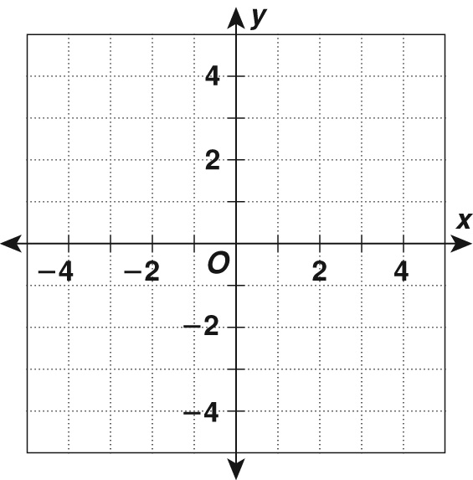
Plot each point on a coordinate plane.
5. (−4, 0)
6. (3, −3)
7. (1, 4)
8. (−5, −1)
9. (−2, 2)
10. (−1, −4)

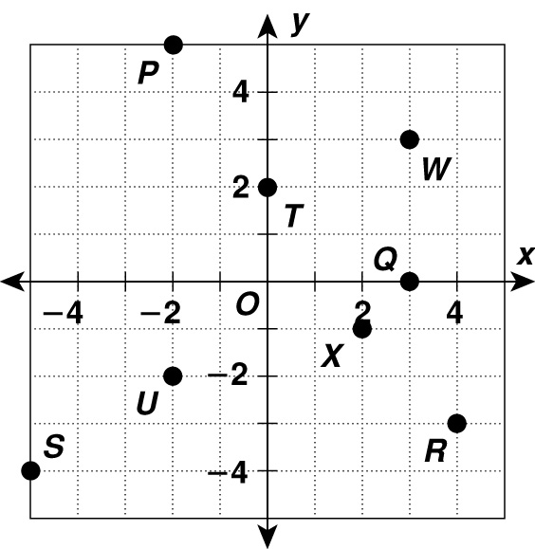
Give the coordinates of each point.
11. P __________________
12. Q __________________
13. R __________________
14. S __________________
15. T __________________
16. U __________________
17. W __________________
18. X __________________
Graphs

Answers for Lesson 1
Practice A
1. I
2. III
3. IV
4. II
5–10.
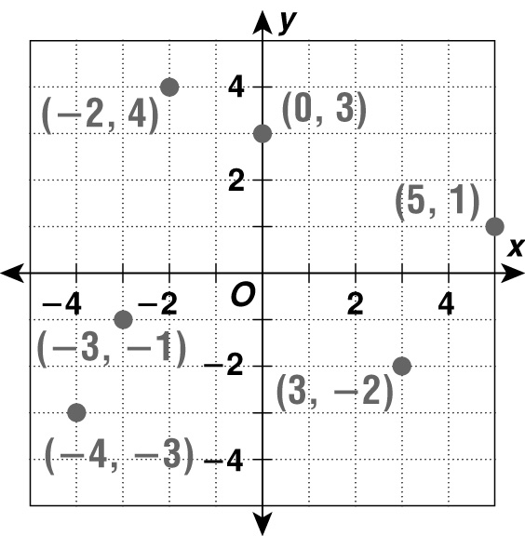
11. (−4, 1)
12. (0, −2)
13. (−3, −3)
14. (5, 2)
15. (3, −4)
16. (4, 0)
17. (2, −1)
18. (−1, 4)
Practice B
1. III
2. IV
3. II
4. I
5–10.
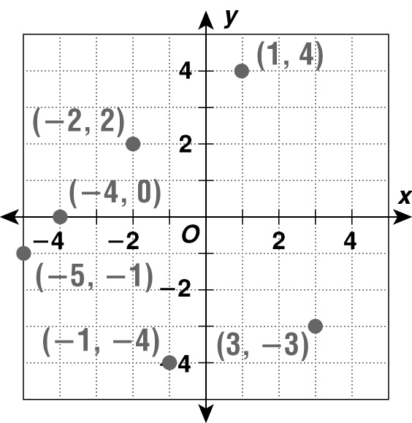
11. (−2, 5)
12. (3, 0)
13. (4, −3)
14. (−5, −4)
15. (0, 2)
16. (−2, −2)
17. (3, 3)
18. (2, −1)
Practice C
1. II; (−2, 5)
2. IV; (3, −3)
3. I; (1, 4)
4. III; (−1, −2)
5-10.
