Graphs

Practice B: Interpreting Graphs
1. The gas tank in Karen’s car was full. Karen drove the car until
only of the tank was full. Karen filled up the tank again and
drove the car until of the tank was full. Which graph best
shows the story? Circle the letter of your answer.
A B C
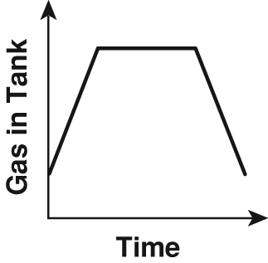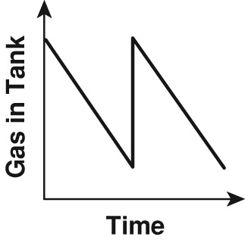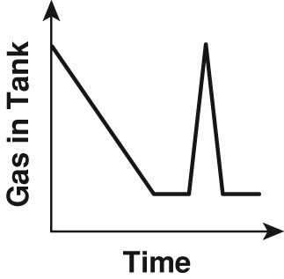

2. An elevator started at the ground floor. It went up to the sixth
floor and stopped, then went to the fourth floor and stopped,
and finally returned to the ground floor. Which graph best shows
the story? Circle the letter of your answer.
F G H
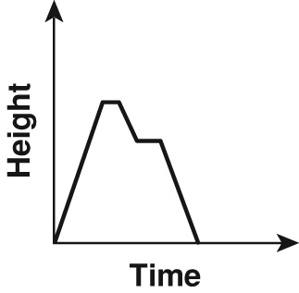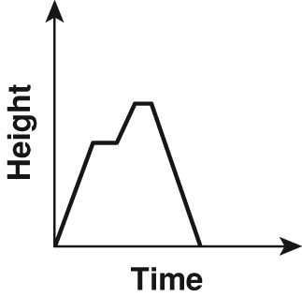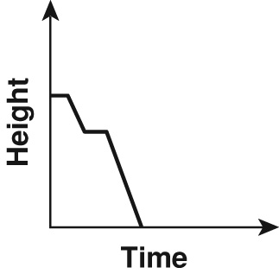

3. Maxine biked 6 miles from her house to the park. She played some softball. Then she biked 4 miles farther to the movie theater. After watching a movie, Maxine returned home. Complete the graph so that it shows the distance Maxine is from home compared to the time.

4. Use your graph to find the total number of miles Maxine biked.

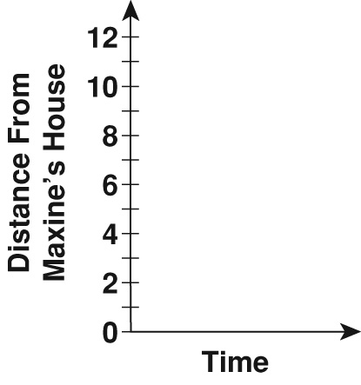

5.
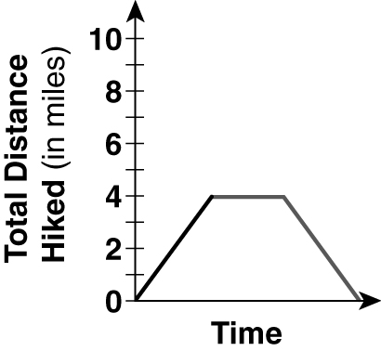
6. 8 miles
Practice B
1. B 2. F
3. 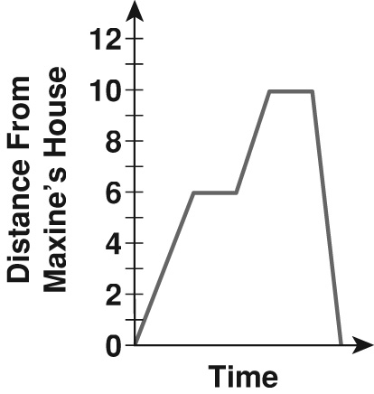
4. 20 miles
Practice C
1. C
2. 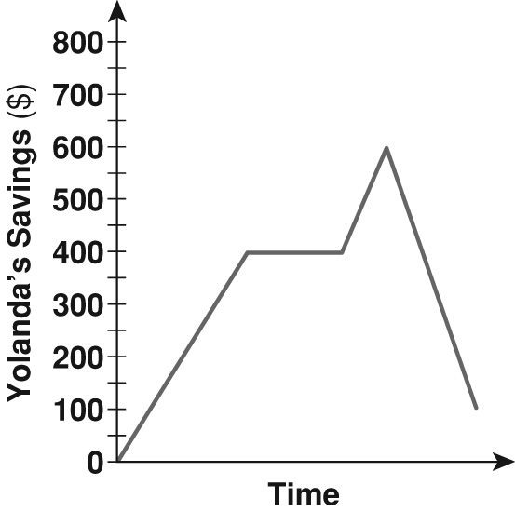
3. $100
4. Possible answer: A skier skis down the slope, waits for the chair lift, goes back up, skis down, waits for the chair lift, and goes back up again.
Review for Mastery
1. 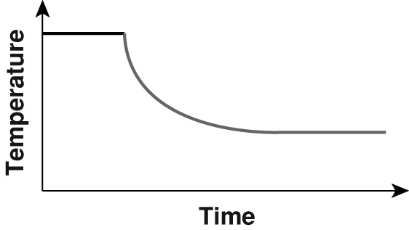
2. 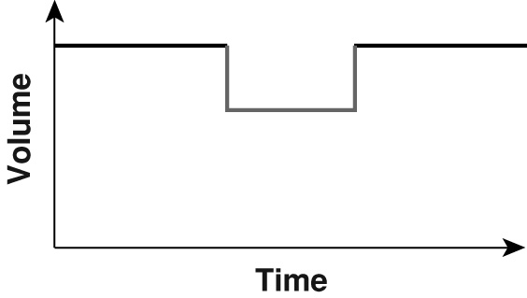
3. 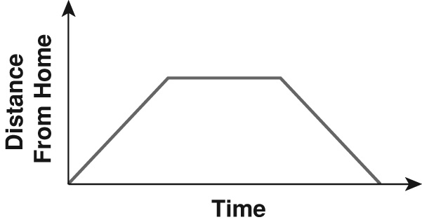
4. 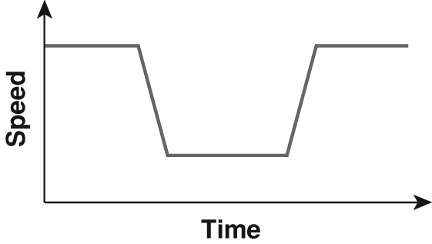
Challenge
1. $0.75 2. $1.25
3. A call of up to 3 minutes costs $0.50. Each additional minute costs $0.25 more.
4. $1.50
5. When a call goes above a whole number of minutes, it charges for the next whole minute. For example, all calls that are greater than 6 minutes and less than or equal to 7 minutes have the same total charge.

