Graphs

Practice B: Slope and Rates of Change
Tell whether the slope is positive or negative. Then find the slope.
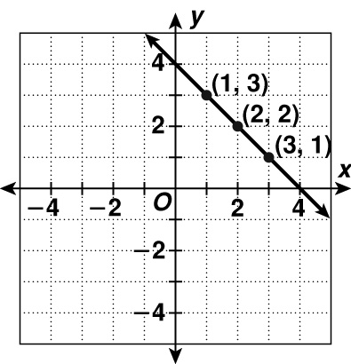
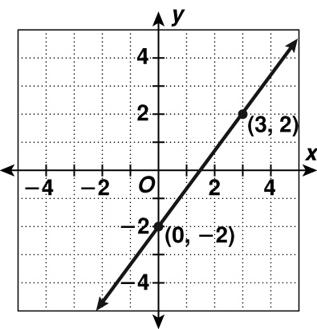
1. 2.

Use the given slope and point to graph each line.
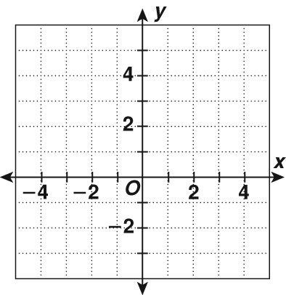
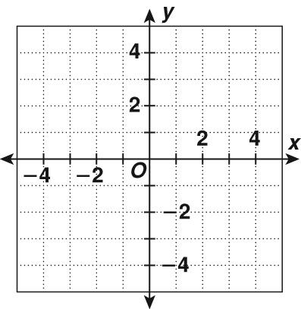
3. −; (2, 4) 4. ; (−1, −2)

Tell whether each graph shows a constant or variable rate of change.
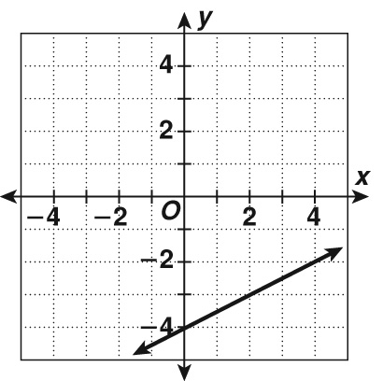
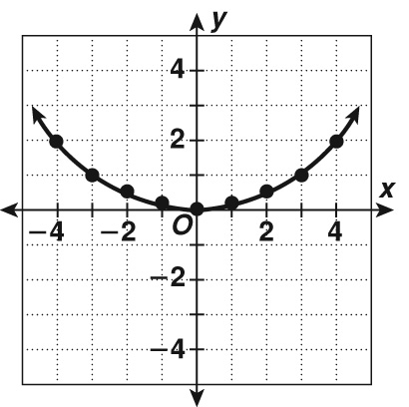
5. 6.

Problem Solving
1. He is walking.
2. He is sprinting at full speed.
3. He begins to sprint.
4. He slows down.
5. A 6. H
7. D
Reading Strategies
1. Hotdog sales increase.
2. The line goes up.
3. The number of hotdog buns decreases.
4. Possible answer: The height of the hotdog stand does not change.
5. There is none.
Puzzles, Twisters & Teasers
1. E
2. I
3. S
4. N
5. L
6. C
S I L E N C E
Answers for Lesson 3
Practice A
1. B 2. D
3. 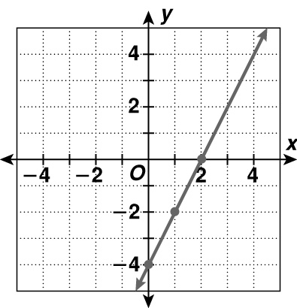
4. 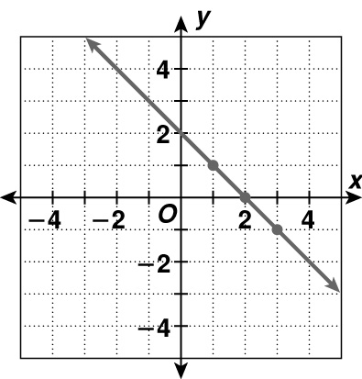
5. constant 6. variable
Practice B
1. negative; −1 2. positive;
3. 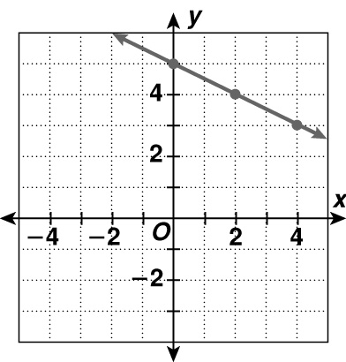
4. 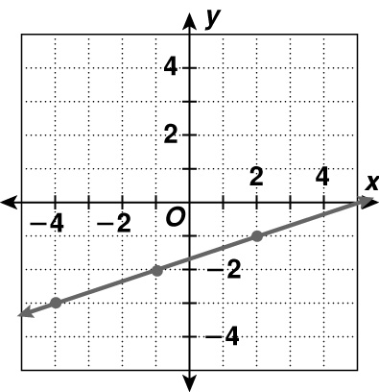
5. constant 6. variable
Practice C
1. 