Graphs

Practice B: Direct Variation
Tell whether each equation represents a direct variation. If so, identify the constant of variation.
1. y = 7x 2. y = 0.04x 3. 3y = 2x + 5

4. y = 13x + 0 5. 4y = 2x 6. 8y = 4x − 12

Tell whether each set of data represents a direct variation. If so, identify the constant of variation and then write the direct variation equation.

7.
x | 10 | 20 | 30
y | 2 | 4 | 6

9.
Times at Bat | 3 | 6 | 12
Hits | 1 | 2 | 4

11.
School days | 18 | 36 | 54
Days Roy was out sick | 2.5 | 6 | 7

8.
x | 2 | 4 | 6
y | 5 | 10 | 15

10.
x | −2 | 8 | 14
y | 3 | 6 | 9

12.
Time (Days) | 1 | 1.3 | 1.6
Distance (k) | 640 | 870 | 1,095

Tell whether each graph represents a direct variation. If so, identify the constant of variation and then write the direct variation equation.

13. 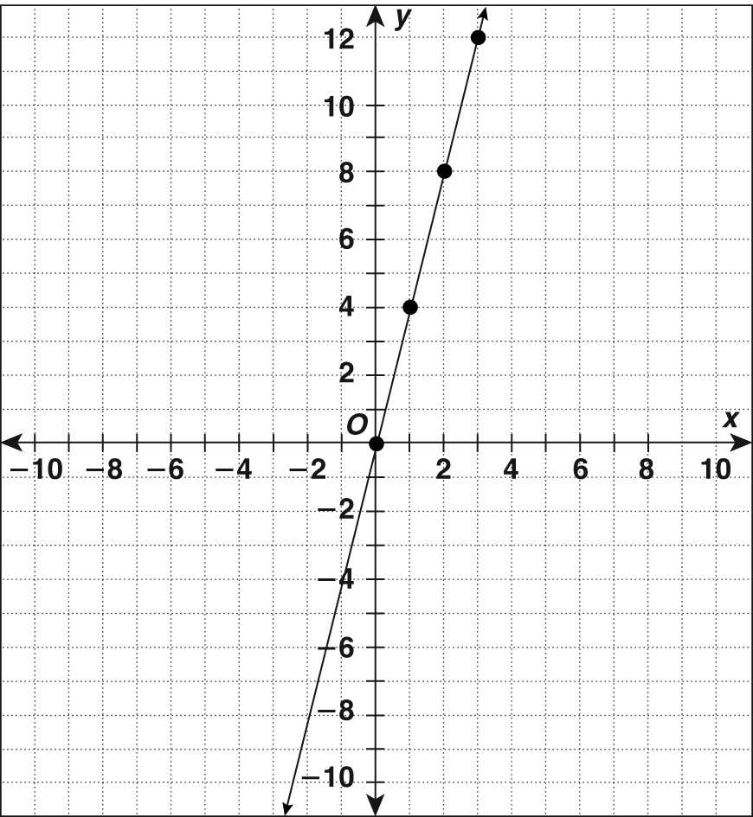

14. 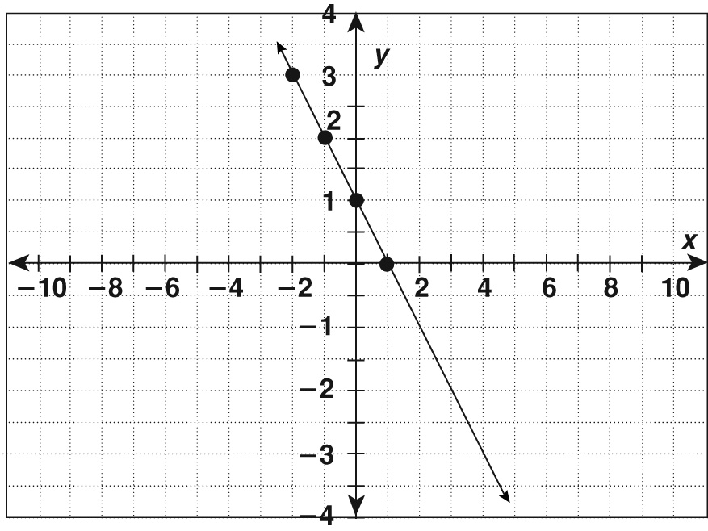

13. no
14. yes, k = 6, y = 6x
Practice B
1. yes, k = 7
2. yes, k = 0.04 3. no
4. yes, k = 13 5. yes, k =
6. no
7. yes,
8. yes,
9. yes, k =,
10. no 11. no
12. no
13. yes, k = 4, y = 4x
14. no
Practice C
1. yes, k = 1.5 2. yes, k =
3. no 4. yes, k =
5. no 6. yes, k = 1.25
7. no
8. yes, k = 0.8, y = 0.8x
9. no 10. no
11. yes, k =,
12. no
Review for Mastery
1. The x variable is days. The y variable is hours.
2. y = 24x 3. 5
4. 1
5. The constant of variation is 2. You divide both sides of the equation by 3.
Challenge
1. 0.7 2. y = 0.7x
3. The earnings for the ninth year will $6.3 million. Multiply 0.7 × 9.
4. No, they do not represent a direct variation. The variation is not constant from year to year.
5. The independent variable is the time in centuries. The dependent variable is the amount of movement. The plates would move 42.5 m in 500 years. They would move 110.5 m in 1,300 years.
Problem Solving
1. It represents a direction variation. The constant of variation is 5,211.
y = 5,211x where y is the number of gallons of gas and x is the number of months.
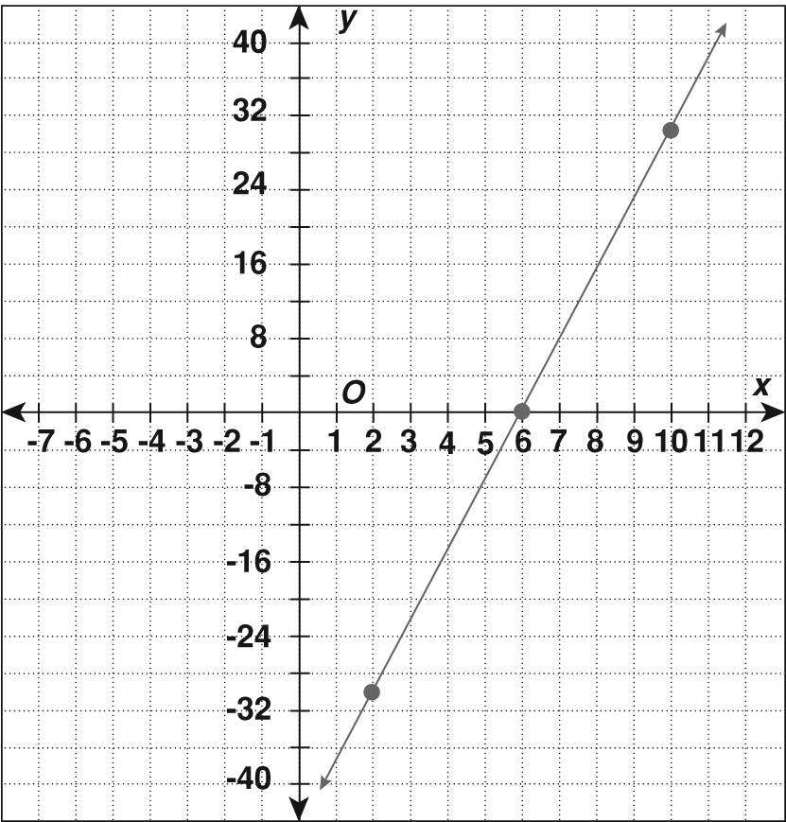
2.

This is not a direct variation.
3. y values: 187.2, 280.8, 842.4.
4. C 5. C
6. B 7. D
Reading Strategies
1. 12 2. 2.3
3. 4.5 4.
5. 1,490 6.
7. y = 8.

