Percents

Practice B: Applications of Percents
Complete the table to find the amount of sales tax for each sale amount to the nearest cent.
1.
Sale amount | 5% sales tax | 8% sales tax | 6.5% sales tax
$67.50
$98.75
$399.79
$1250.00
Complete the table to find the commission for each sale amount to the nearest cent.
2.
Sale amount | 6% commission | 9% commission | 8.5% commission
$475.00
$2450.00
$12,500.00
$98,900.00
3. Alice earns a monthly salary of $315 plus a commission on
her total sales. Last month her total sales were $9640, and
she earned a total of $1182.60. What is her commission rate? ______________
4. Phillipe works for a computer store that pays a
12% commission and no salary. What will Phillipe’s weekly
sales have to be for him to earn $360? ______________
5. The purchase price of a book is $35.85. The sales tax rate is
6.5%. How much is the sales tax to the nearest cent? What
is the total cost of the book?

6. Salesperson A made 11% of $67,530. Salesperson B made
8% of $85,740. Who made more commission this month?
How much did she make?

7. Jon earned $38,000 last year. He paid $6,840 towards
entertainment. What percent of his earnings did Jon pay
in entertainment expenses? ______________
8. The Cougars won 62% of their games. They won
93 games. How many games did they lose? ______________
17. $704.88; $5,169.12
18. $225.25 19. 231.8%
Review for Mastery
1. 14 2. 9
8 90
; 175 ; 10
3. 75 4. 340
125 400
; 60 ; 85
5. 25% 6. 95%
7. 80% 8. 40%
9. 200% 10. 5%
Challenge
1. 289; 332 2. 189; 204
3. $4.70; $3.76 4. 419
5. $1.27
6. Fun Electronics, since the game will cost $40.96; it will cost $41.36 at Gamers.
Problem Solving
1. about 7.6 million cars
2. 31.1% increase
3. 3% increase 4. 137 pounds
5. 36.2% increase
6. 15.8% decrease
7. C 8. G
9. C 10. J
Reading Strategies
1. $50 2. decrease
3. in the denominator (or bottom part) of the fraction
4. 25 5. 20
6.
Puzzles, Twisters & Teasers
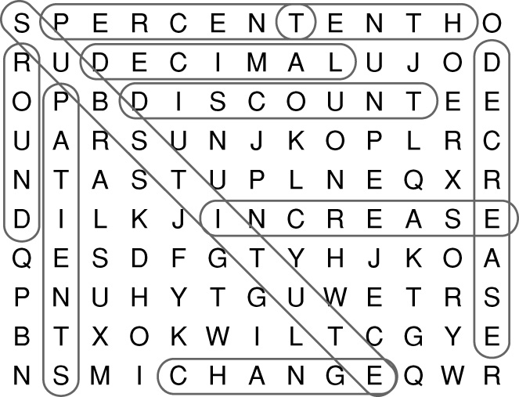

P A T I E N T S
Answers for Lesson 5
Practice A
1. c = 0.1 • 4000
2. c = 0.06 • 8450
3. c = 0.08 • 3575
4. c = 0.12 • 12,750
5. c = 0.055 • 60,000
6. c = 0.0625 • 85,900
7. 8.
9. 10.
11. 180 12. 12.5%
13. $2000 14. $62.79
15. 15% 16. $3000
Practice B
1.
5% sales  tax | 8% sales  tax | 6.5% sales tax
$3.38 | $5.40 | $4.39
$4.94 | $7.90 | $6.42
$19.99 | $31.98 | $25.99
$62.50 | $100.00 | $81.25

2.
6% commision | 9% commision | 8.5% commission
$28.50 | $42.75 | $40.38
$147.00 | $220.50 | $208.25
$750.00 | $1125.00 | $1062.50
$5934.00 | $8901.00 | $8406.50
3. 9%
4. $3000
5. sales tax is $2.33; total cost is $38.18
6. Salesperson A $7428.30
7. 18%
8. 57 games
Practice C
1. $756 2. $1160.34
3. $66.70 4. $2515.80
5. $518.75 6. $5860
7. $9828 8. $15,000
9. $41.04 10. 6.25%
11. 32% 12. $2295.25
13. 8.5%
Review for Mastery
1. 170,000; 5100; 5100; 6600
2. 0.055; 16,000; 880; 880; 1750; 2630
3. 5.19; 0.3114; 0.31
4. 0.0675; 250; 16.875; 16.88
5. 837 6. 1900
837 1900; 304
83,700 1900n; 30,400
;
27 16
27% 16%
Challenge
1. $179.80; $719.20
2. $2.25; $12.74
3–6. Possible answers are given:
3. 50% discount: $50 for 1 item and $100 for 2 items;
2nd item half price: $100 for first item and $150 for 2 items
4. Buy 2, get 1 free: $200 for 3 items;
33% discount: $200 for 3 items
5. 20% discount on $100 item: pay $80;
After first 10% discount, item price is $90. Now, take 10% off $90 and final price is $81.
6. The additional 50% is off 50% of the reduced price. The item is 25% of the original price.
Problem Solving
1. $33.75 2. $2.50
3. 29% 4. $1500
5. A 6. G
7. C 8. H
Reading Strategies
1. sales tax
2. commission
3. commission rate
4. total sale
Puzzles, Twisters & Teasers
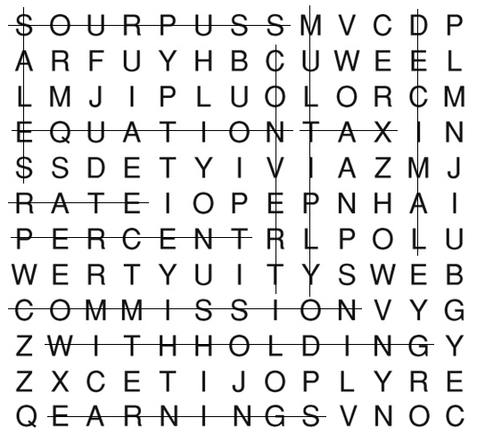SOURPUSS

