Collecting, Displaying, and Analyzing Data

Practice B: Populations and Samples
1. Determine which sampling method will better represent the
entire population. Justify your answer.

Reading Habits of High School Students
Sampling Method | Results of Survey
Dinah surveys 48 students who she knows. | 91% have read a novel in the past month.
Suki gives survey forms to 100 students who were randomly chosen from a school attendance list. | 59% have read a novel in the past month.

For Problems 2 and 3, determine whether each sample may be biased. Explain.
2. An on-line bookseller randomly chooses 200 book buyers from its database and then surveys those book buyers to find out if they were satisfied with the time it took to deliver their orders.

3. Milena surveys 80 high school students who are leaving a jazz concert to determine the favorite type of music among high school students.

4. Zack chooses a random sample of 50 out of 400 students. He finds that 7 of them have traveled to a foreign country. Zack claims that over 50 of the 400 students have traveled to a
foreign country. Do you agree? Explain your answer.

5. A mint produces 150,000 souvenir coins each year. In a random sample of 400 coins, 3 have a misprint. Predict the number of coins that will have misprints in a year.

Review for Mastery
1. 20 24 25 27 31 35 38
2. 20, 38, and 27 3. 24, 35
4. 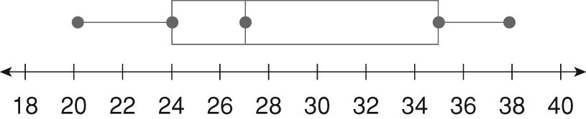
5. 61 63 65 68 69 70 72 74 78
6. 61, 78 7. 69, 64, and 73
8. 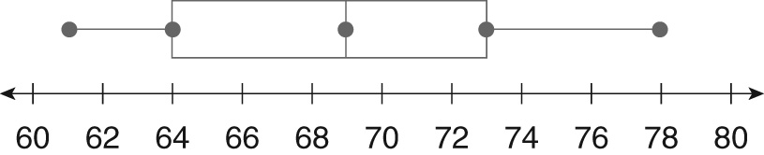
Challenge
1. 10; 24 2. 18
3. The median is a number in the data set. When there are an odd number of numbers, the median is the middle number.
4. 12, 23
5. Yes. Since the lower and upper halves of the data each have an odd number of numbers, the median of each is the middle number in each.
6. 16, 22
7. 6, 9, 10, 12, 14, 15, 20
Problem Solving
1. Class B; 8 2. Class B
3. Class A 4. 25%
5. B 6. H
7. D 8. J
Reading Strategies
1. the middle half of the data
2. The whiskers extend from both ends of the box to the least and greatest values.
3. It divides the set of data in half.
4. least value; lower quartile
5. upper quartile; greatest value
6. median; upper quartile
Puzzles, Twisters & Teasers
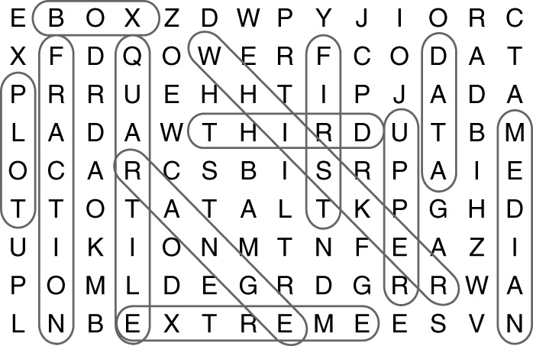
M T (empty)

Answers for Lesson 3
Practice A
1. b 2. a
3. The sample is biased. Possible explanation: It is likely that people who use the library will not have the same opinion as people who do not use the library.
4. The sample is not biased. It is a random sample.
5. The sample is biased. Possible explanation: It is likely that students who are not on sports teams will not have the same opinion as students who are on sports teams.
6. Yes; = , and 48 < 50
Practice B
1. Suki’s method will better represent the entire student population because she uses a random sample. Dinah’s method produces results that are not as representative of the entire population because she uses a convenience sample.
2. The sample is not biased. It is a random sample.
3. The sample is biased. Possible explanation: It is likely that not all high school students will choose the same kind of music as the kind chosen by those who attend a jazz concert.
4. Yes; = , and 56 > 50
5. 1,125 coins will have misprints.
Practice C
1. Wanda’s method will better represent the entire employee population because she uses a random sample. Bernard’s method will produce results that are not as representative of the entire population because his sample is not random.
2. The sample is biased. Possible explanation: It is likely that not all tenants will give the same answer as those tenants who use e-mail.
3. The sample is not biased. It is a random sample.
4. Possible answer: You would survey the entire population because the population is small.
5. Possible answer: You would use a sample because the entire population is large.
Review for Mastery
1. The sample is biased. The passengers on one on-time flight are likely to feel differently about their flight than passengers on some other flights.
2. The sample is not biased. It is a random sample.
3. The sample is not biased. It is a random sample.
4. The sample is biased. The people who go to movies are not likely to spend amounts of money on entertainment that are similar to the amounts spent by other people in the state.
Challenge
1. systematic 2. cluster
3. stratified 4. stratified
5. cluster 6. stratified
7. systematic 8. cluster
9. systematic 10. stratified
Problem Solving
1. No; Not all children are likely to have the same exercise habits as children who go to a sporting goods store.
2. Possible answer: She should survey the entire population, since it is relatively small.
3. 300 fish 4. 540 students
5. D 6. F
Reading Strategies
1. Population is everyone and a sample is part of the population.
2. An unbiased sample represents the population and a biased sample does not.
3. biased sample
4. unbiased sample
5. biased sample
Puzzles, Twisters & Teasers
1. O
2. N
3. D
4. K
5. M
D O N O T S M O K E

