Applying Rational Numbers

Practice B: Adding and Subtracting Decimals
Add. Estimate to check whether each answer is reasonable.
1. 6.14 + 8.91 2. 4.51 + 13.08 3. 12.54 + 21.08

4. 34.22 + (−18.5) 5. −10.10 + (−5.9) 6. 6.87 + (−31.6)

7. 9 + 5.68 8. −15.51 + 8.55 9. 36.36 + 54.54

Subtract.
10. 6.23 − 3.62 11. 8.67 − 6.87 12. 28.94 − 9.48

13. 23.57 − 6.84 14. 16.61 − 7.56 15. 32.08 − 12.37

16. 19 − 6.92 17. 42 − 31.89 18. 23 − 21.45

19. 46.2 − 0.27 20. 22 − 18.63 21. 58.9 − 29.58

22. Anna swims the length of the pool in 38.45 seconds and then swims the length of the pool again in 42.38 seconds. What is her total time for 2 lengths of the pool?

23. Po has 2 gerbils named Yip and Yap. Yip weighs 3.62 ounces, and Yap weighs 2.79 ounces. How much heavier is Yip than Yap?

Applying Rational Numbers

Answers for Lesson 1
Practice A
1. 9; 8; 5 2. 2; 2; 2; 3
3. 1; 1; 5; 7 4. 2; 6; 5
5. 2.36 6. 31.299
7. 33.176 8. 6; 6; 7
9. 2; 0; 6 10. 3.8
11. 5.4 12. 5.2
13. 7.12 14. 3.5
15. 9.68
Practice B
1. 15.05 2. 17.59
3. 33.62 4. 15.72
5. −16 6. −24.73
7. 14.68 8. −6.96
9. 90.9 10. 2.61
11. 1.8 12. 19.46
13. 16.73 14. 9.05
15. 19.71 16. 12.08
17. 10.11 18. 1.55
19. 45.93 20. 3.37
21. 29.32 22. 80.83 seconds
23. 0.83 ounce
Practice C
1. 16.816 2. 2.975
3. 46.718 4. 1.175
5. 12.979 6. −29.491
7. −2.716 8. 23.392
9. −81.632 10. 38.026
11. −30.774 12. −7.259
13. 24.591 14. 111.105
15. −81.054 16. 17.99
17. 36.054 18. 36.794
19. 54.732 20. 90.559
21. 66.837 22. 39.581
23. 39.35 mi/h
24. 24.355 kilograms
Review for Mastery
1. 28.12 2. 2.07
3. 15.66 4. 49.96
5. 43.9 6. 29.68
7. 37.57
Challenge
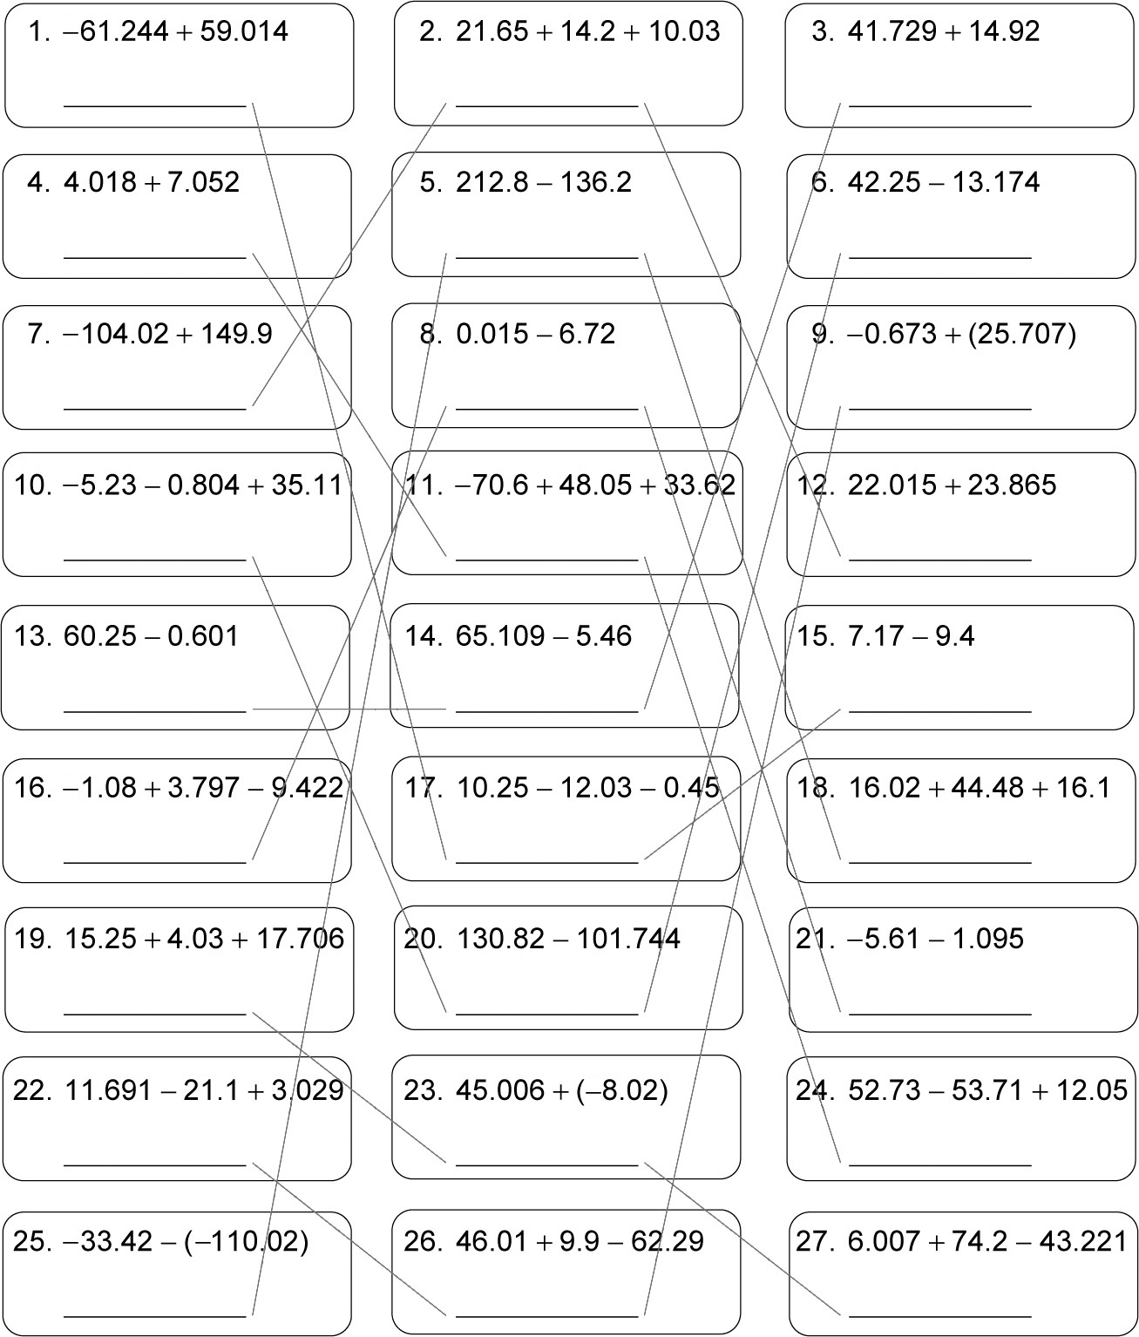

−2.23 45.88 59.649
11.07 76.6 29.076
45.88 −6.705 −6.38
29.076 11.07 45.88
59.649 59.649 −2.23
−6.705 −2.23 76.6
36.986 29.076 −6.705
−6.38 36.986 11.07
76.5 −6.38 36.986
Problem Solving
1. 3.93 kilometers 2. 4.2 kilometers
3. 4.39 kilometers 4. −4.9 ºC
5. A 6. H
7. B
Reading Strategies
1. One number is placed in each square.
2. as a placeholder to show that there is no number in that place

