Prompt 1: National geographic article on Nuclear reactor
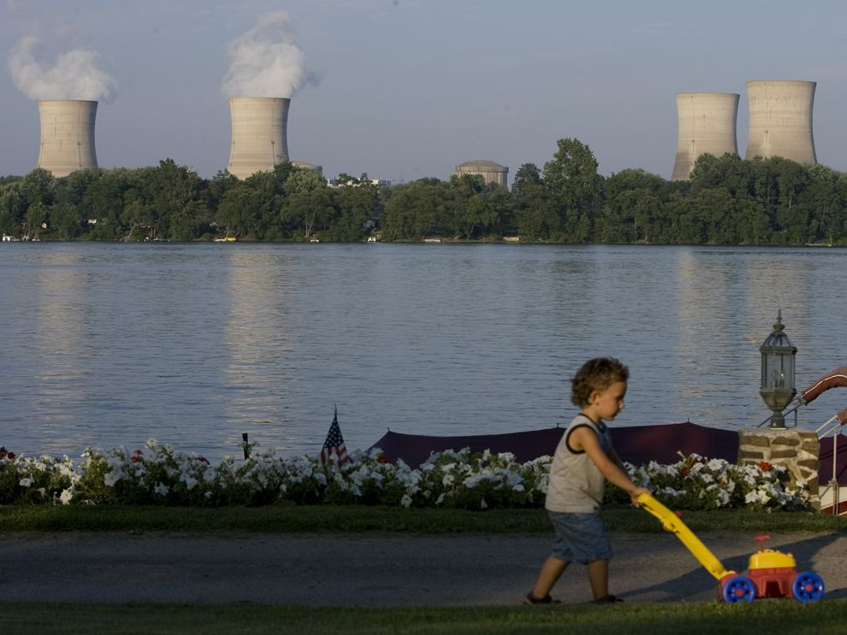
The Three Mile Island nuclear power plant, near Harrisburg, Pennsylvania, is capable of generating 892 net megawatts of electricity. That is enough to power more than 800,000 homes and businesses. In 1979, part of the Three Mile Island facility suffered a meltdown and was never reopened.near Harrisburg, Pennsylvania, is capable of generating 892
Nuclear energy is the energy in the nucleus, or core, of an atom. Atoms are tiny units that make up all matter in the universe. Energy is what holds the nucleus together. There is a huge amount of power in an atoms dense nucleus. In fact, the power that holds the nucleus together is officially called the "strong force.
Nuclear energy can be used to create electricity, but it must first be released from the atom. In nuclear fission, atoms are split to release the energy.
A nuclear reactor, or power plant, is a series of machines that can control nuclear fission to produce electricity. The fuel that nuclear reactors use to produce nuclear fission is pellets of the element uranium. In a nuclear reactor, atoms of uranium are forced to break apart. As they split, the atoms release tiny particles called fission products. Fission products cause other uranium atoms to split, starting a chain reaction. The energy released from this chain reaction creates heat.
The heat created by nuclear fission warms the reactors cooling agent. A cooling agent is usually water, but some nuclear reactors use liquid metal or molten salt. The cooling agent, heated by nuclear fission, produces steam. The steam turns turbines, or wheels turned by a flowing current. The turbines drive generators, or engines that create electricity.
Rods of material called nuclear poison can adjust how much electricity is produced. Nuclear poisons are materials, such as a type of the element xenon, that absorb some of the fission products created by nuclear fission. The more rods of nuclear poison that are present during the chain reaction, the slower and more controlled the reaction will be. Removing the rods will allow a stronger chain reaction and create more electricity.
About 15 percent of the worlds electricity is generated by nuclear power plants. The United States has more than 100 reactors, although it creates most of its electricity from fossil fuels and hydroelectric energy. Nations such as Lithuania, France, and Slovakia create almost all of their electricity from nuclear power plants.
Nuclear Food: Uranium
Uranium is the fuel most widely used to produce nuclear energy. Thats because uranium atoms split apart relatively easily. Its also a very common element, found in rocks all over the world. However, the specific type of uranium used to produce nuclear energy, called U-235, is rare. U-235 makes up less than one percent of the uranium in the world.
Although some of the uranium the United States uses is mined in this country, most is imported. The U.S. gets uranium from Australia, Canada, Kazakhstan, Russia, and Uzbekistan. Once uranium is mined, it must be extracted from other minerals. It must also be processed before it can be used.
Because nuclear fuel can be used to create nuclear weapons as well as nuclear reactors, only nations that are part of the Nuclear Non-Proliferation Treaty (NPT) are allowed to import uranium or plutonium, another nuclear fuel. The treaty promotes the peaceful use of nuclear fuel, as well as limiting the spread of nuclear weapons.
A typical nuclear reactor uses about 200 tons of uranium every year. Complex processes allow some uranium and plutonium to be re-enriched or recycled. This reduces the amount of mining, extracting, and processing that needs to be done.
Nuclear Energy and People
Nuclear energy produces electricity that can be used to power homes, schools, businesses, and hospitals. The first nuclear reactor to produce electricity was located near Arco, Idaho, in the U.S. The Experimental Breeder Reactor began powering itself in 1951. The first nuclear power plant designed to provide energy to a community was established in Obninsk, Russia, in 1954.
Building nuclear reactors requires a high level oftechnology, and only the countries that have signed the Nuclear Non-Proliferation Treaty can get the uranium or plutonium that is required. For these reasons, most nuclear power plants are located in the developed world.
Nuclear power plants produce renewable, clean energy. They do not pollute the air or produce greenhouse gases. They can be built in urban or rural areas, and do notradically alter the environment around them.
The steam powering the turbines and generators is ultimately recycled. It is cooled down in a separate structure called a cooling tower. The steam turns back into water and can be used again to produce more electricity. Excess steam is simply recycled into the atmosphere, where it does no harm as clean water vapor.
However, the byproduct of nuclear energy is radioactivematerial. Radioactive material is a collection of unstable atomic nuclei. These nuclei lose their energy and can affect many materials around them, including organisms and the environment. Radioactive material can be extremely toxic, causing burns and increasing the risk forcancers, blood diseases, and bone decay.
Radioactive waste is what is left over from the operation of a nuclear reactor. Radioactive waste is mostly protective clothing worn by workers, tools, and cloths that have been in contact with radioactive dust. Radioactive waste is long-lasting. Materials like clothes and tools can stay radioactive for thousands of years. The government regulates how these materials are disposed of so they dont contaminate anything else.
Used fuel and rods of nuclear poison are extremely radioactive. The used uranium pellets must be stored in special containers that look like large swimming pools. Water cools the fuel and insulates the outside from contact with the radioactivity. Some nuclear plants store their used fuel in dry storage tanks above ground.
The storage sites for radioactive waste have become very controversial in the United States. For years, the government planned to construct an enormous nuclear waste facility near Yucca Mountain, Nevada, for instance. Environmental groups and local citizens protested the plan. They worried about radioactive waste leaking into the water supply and the Yucca Mountain environment, about 130 kilometers (80 miles) from the large urban area of Las Vegas, Nevada. Although the government began investigating the site in 1978, it stopped planning for a nuclear waste facility in Yucca Mountain in 2009.
Chernobyl
Critics of nuclear energy worry that the storage facilities for radioactive waste will leak, crack, or erode. Radioactive material could then contaminate the soil and groundwaternear the facility. This could lead to serious health problems for the people and organisms in the area. All communities would have to be evacuated.
This is what happened in Chernobyl, Ukraine, in 1986. A steam explosion at one of the power plants four nuclear reactors caused a fire, called a plume. This plume was highly radioactive, creating a cloud of radioactive particles that fell to the ground, called fallout. The fallout spread over the Chernobyl facility, as well as the surrounding area. The fallout drifted with the wind, and the particles entered the water cycle as rain. Radioactivity traced to Chernobyl fell as rain over Scotland and Ireland. Most of the radioactive fallout fell in Belarus.
The environmental impact of the Chernobyl disaster wasimmediate. For kilometers around the facility, the pineforest dried up and died. The red color of the dead pines earned this area the nickname the Red Forest. Fish from the nearby Pripyat River had so much radioactivity that people could no longer eat them. Cattle and horses in the area died.
More than 100,000 people were relocated after thedisaster, but the number of human victims of Chernobyl is difficult to determine. The effects of radiation poisoningonly appear after many years. Cancers and other diseases can be very difficult to trace to a single source.
Future of Nuclear Energy
Nuclear reactors use fission, or the splitting of atoms, to produce energy. Nuclear energy can also be produced through fusion, or joining (fusing) atoms together. The sun, for instance, is constantly undergoing nuclear fusion as hydrogen atoms fuse to form helium. Because all life on our planet depends on the sun, you could say that nuclear fusion makes life on Earth possible.
Nuclear power plants do not have the capability to safely and reliably produce energy from nuclear fusion. Its not clear whether the process will ever be an option for producing electricity. Nuclear engineers are researching nuclear fusion, however, because the process will likely be safe and cost-effective.

Prompt 2 : Energy chart
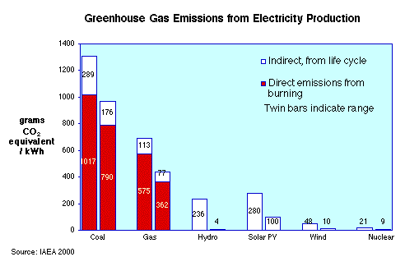

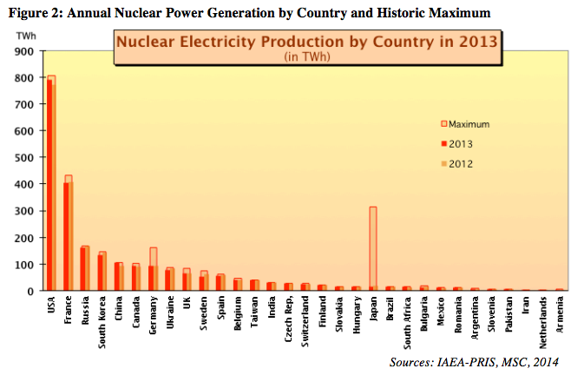
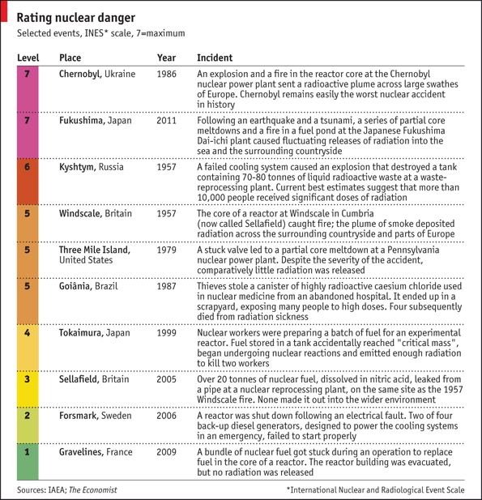

Prompt 3: Video
James Hansen on Nuclear Energy – YouTube
https://www.youtube.com/watch?v=alrxqx_B34s
Nov 16, 2010 - 1 min - Uploaded by Newsweek Magazine
"I think that next-generation, safe nuclear power is an option which we need to develop. And it is being developed in many countries around the world. So if the United States declines to do that, we're just going to suffer economically because other countries will take the lead in that technology." - James Hansen
Recorded January 26, 2010 | CitizenTube YouTube Newsweek
- Category
  - News & Politics
- License
  - Standard YouTube License

Rationale:
You probably know that most of the electricity you use is produced in a power plant. Nuclear energy is one of the possible sources to generate electricity. Presently it is widely used in Europe but limited use in United State. They are looking to build new nuclear power plant in many areas.
Task:
You are a congresswoman’s chief-of-staff and she needs your help coming up with a position on whether a nuclear power plant should be built in the district.
You have reviewed three sources regarding use of nuclear energy in generating electricity. These three pieces provide information regarding the pros and cons of nuclear energy in power plant.
Source 1: National geographic article
Source 2: Energy chart
Source 3: You tube video on Nuclear energy https://www.youtube.com/watch?v=alrxqx_B34s
Your task is to write a position paper that addresses use of nuclear energy and support your position with evidence from at least two of the three sources. Be sure to acknowledge the opposing views. Support your claim with the evidences provided in all three sources.

