1663
Cause
England enters the Atlantic slave trade business.
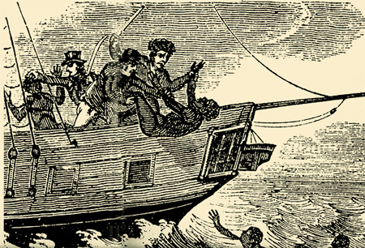
Cause/Effect
“Between 1761 and 1808, British traders hauled across the Atlantic 1,428,000 African captives and pocketed £60 million - perhaps £8 billion in today's money - from slave sales.

Effect – Britain Supply of Money
“A study of the activities of 23 London merchants who were heavily involved in the slave trade found they 'played their part in building roads and bridges ... They invested in [other] maritime undertakings, ...; mining,...., coal..”

Works Cited
Blackburn, Robin. "Enslavement and Industrialisation." BBC. (2011): 4. Web. 29 Jan. 2013. <http://www.bbc.co.uk/history/british/abolition/industrialisation_article_01.shtml>.

