|  |
| --- |
| **Biology**  **Post Assessment Study Guide** |

Name_______Answer Key___________________ Date_____________________ Period__________

1. Complete the following analogies
   1. Amino acid is to protein as simple sugar is to ___carbohydrate______.
   2. Nucleic Acid is to nucleotide as ____protein____ is to amino acid.
2. What is the pH range of an acid? Base? What pH is neutral?

Acid ~ less than 7

Base~ greater than 7

Neutral~ 7

1. Look at the table below.

|  |  |
| --- | --- |
| Vitamin dose per day | Number of cells |
| 0 | 29.3 |
| 0.10 | 44.9 |
| 0.20 | 32.1 |
| 0.50 | 15.2 |

The scientist hypothesized that cell division would decrease as concentrations of vitamin increase. The table above summarizes the results of the experiment.

**What can you conclude from the data shown in the table?**

**The hypothesis is incorrect. Increasing vitamin dose results in random increase and decrease of cells.**

1. Water is a polar molecule. What is the charge of the oxygen end of a water molecule? What type of charged substance would the oxygen end of the water molecule be attracted to? Why?

Oxygen has a negative charge. It would be attracted to a positively charged substance because opposite charges attract each other.

1. What does permeable mean?

If something is permeable, then it is able to pass across the cell membrane.

1. In terms of concentration, how do substances diffuse across the cell membrane?

They diffuse from areas of high concentration to low concentration

1. What part of a lab report should students/scientists state the hypothesis and give any relevant background in formation?

Introduction

1. After scientists run an experiment and draw conclusions, what are the next steps they should follow?

They should repeat the experiment to see if they get the same results each time.

1. What is the control group if an experiment? Why is it necessary to have one?

The control group does not contain the variable. You need it to compare your results to the experimental group.

1. Study the following graphs:



**How could you slow down the activity of this enzyme?**

**You could decrease the temp below 40 or increase the temp above 40. You could also change the pH to either above or below 7.**

**What temperature would cause the enzyme to denature?**

**60 (high temps above 40)**

1. What moves across the membrane through osmosis?

water

1. Why is water essential to photosynthesis? Explain the role it plays in the Light Dependent Reactions.

Water replaces electrons in chlorophyll that were lost in the light dependent reactions. Without electrons, the energy can not be transferred to NADP+

1. What do the stages of mitosis look like? Know them in order.

Prophase, metaphase, anaphase, telophase Know the diagrams from the book

1. Which of the following graphs represents the effect of increased temperature on photosynthesis? (**X-axis is temp and Y-axis is amount of sugar produced)**

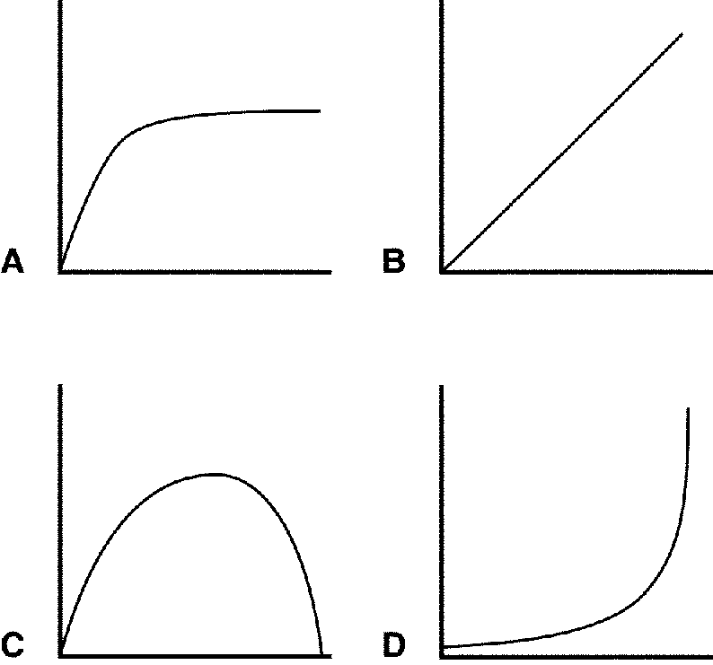

Answer = A

1. What are two ways energy can be released from breaking down glucose?

Anaerobic (fermentation) and aerobic resoiration (cell respiration)

1. What type of respiration requires the presence of mitochondria?

Cell respiration (aerobic)

1. Can cells get energy from glucose without mitochondria? Explain.

Yes, but not as much. They can get energy from Glycolysis (2 ATP)

1. Why does meiosis lead to greater variation? Explain

During prophase 1, the homologous chromosomes exchange pieces (crossing over). There is genetic recombination.

1. How are mitosis and meiosis different? How are they similar?

Different: Mitosis produces 2N (diploid) cells. Asexual reproduction.

Meiosis produces N (haploid) cells that are used in sexual reproduction.

Similar: Both begin with 2N chromosomes. Both are types of cell division. Both require DNA replication before division(during interphase)

1. A dominant allele codes for white hair (W). If a parent with Ww is crossed with another parent ww, what is the % their offspring will have white hair?

|  |  |  |
| --- | --- | --- |
|  | W | w |
| w | Ww | ww |
| w | Ww | ww |

50% white hair

1. A homozygous running, heterozygous black mouse is crossed with a waltzing, brown mouse. What are the chances they will have a running, black mouse?

RRBb x rrbb

RB rb 50% running, black

Rb

|  |  |  |
| --- | --- | --- |
|  | RB | Rb |
| rb | RrBb | Rrbb |

1. “The presence of water could accelerate the growth of mold (If there is water then it will accelerate the growth of mold)” What part of the scientific method does this represent?

Hypothesis