|  |
| --- |
| **Biology**  **Post Assessment Study Guide** |

Name______________________________________ Date_____________________ Period__________

1. Complete the following analogies
   1. Amino acid is to protein as simple sugar is to ____________________.
   2. Nucleic Acid is to nucleotide as _________________ is to amino acid.
2. What is the pH range of an acid? Base? What pH is neutral?
3. Look at the table below.

|  |  |
| --- | --- |
| Vitamin dose per day | Number of cells |
| 0 | 29.3 |
| 0.10 | 44.9 |
| 0.20 | 32.1 |
| 0.50 | 15.2 |

The scientist hypothesized that cell division would decrease as concentrations of vitamin increase. The table above summarizes the results of the experiment.

**What can you conclude from the data shown in the table?**

1. Water is a polar molecule. What is the charge of the oxygen end of a water molecule? What type of charged substance would the oxygen end of the water molecule be attracted to? Why?
2. What does permeable mean?
3. In terms of concentration, how do substances diffuse across the cell membrane?
4. What part of a lab report should students/scientists state the hypothesis and give any relevant background in formation?
5. After scientists run an experiment and draw conclusions, what are the next steps they should follow?
6. What is the control group if an experiment? Why is it necessary to have one?
7. Study the following graphs:



**How could you slow down the activity of this enzyme?**

**What temperature would cause the enzyme to denature?**

1. What moves across the membrane through osmosis?
2. Why is water essential to photosynthesis? Explain the role it plays in the Light Dependent Reactions.
3. What do the stages of mitosis look like? Know them in order.
4. Which of the following graphs represents the effect of increased temperature on photosynthesis? (**X-axis is temp and Y-axis is amount of sugar produced)**

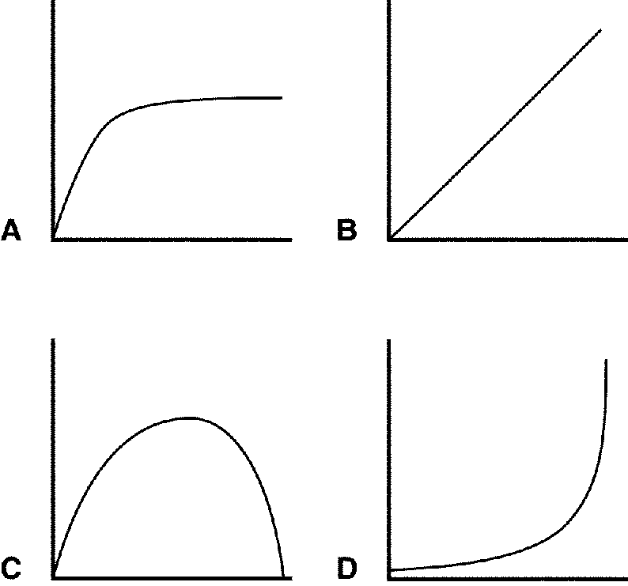

1. What are two ways energy can be released from breaking down glucose?
2. What type of respiration requires the presence of mitochondria?
3. Can cells get energy from glucose without mitochondria? Explain.
4. Why does meiosis lead to greater variation? Explain
5. How are mitosis and meiosis different? How are they similar?
6. A dominant allele codes for white hair (W). If a parent with Ww is crossed with another parent ww, what is the % their offspring will have white hair?
7. A homozygous running, heterozygous black mouse is crossed with a waltzing, brown mouse. What are the chances they will have a running, black mouse?
8. “The presence of water could accelerate the growth of mold (If there is water then it will accelerate the growth of mold)” What part of the scientific method does this represent?