

**HEREDITY** = passing on of characteristics from parents to offspring

* + - * How?.................**DNA!**

**I. DNA, Chromosomes, Chromatin, and Genes**

* + - * **DNA** = blueprint of life (has the instructions for making an organism)

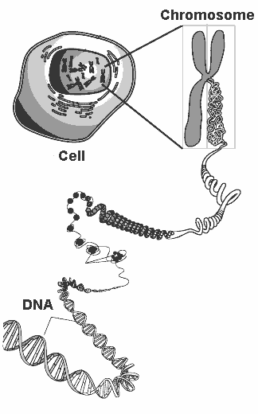

Gene

* + - * **Chromatin**= uncoiled DNA
      * **Chromosome** = coiled DNA
      * You have 46 chromosomes or 23 pairs in the **nucleus** of each body cell.
        + 23 from mom and 23 from dad
      * **Gene** = a segment of DNA that codes for a protein, which in turn codes for a trait (skin tone, eye color, etc); a gene is a stretch of DNA.
        + There is a gene for every protein your body has to make.

**II. DNA**

* + - * Deoxyribonucleic Acid
      * Located in the **nucleus** of the cell
      * Codes for your **genes**
      * **Frank Griffith**- discovered DNA in 1928

**A. SHAPE & STRUCTURE:**

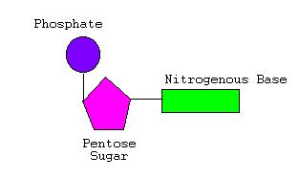

* + - * + DNA nucleotide components:

**Deoxyribose** (simple sugar)

**Phosphate group**

**Nitrogen bases (A,T, C, G)**

* + - * + Shaped similar to a twisted ladder…aka…**double helix**!
        + The uprights of this ladder are composed of **phosphates** and **deoxyribose** **sugar**
        + The rungs are composed of 2 bases (a purine and pyrimidine) joined at the center by weak **hydrogen** bonds.

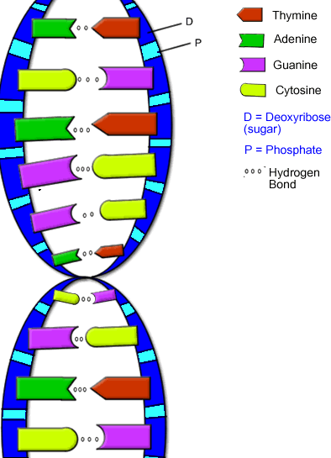

**Purines** = adenine (A) and guanine (G)

**Pyrimidines** = thymine (T) and cytosine (C)

**B. BASE PAIRING:**

* + - * + 1962: **James Watson** and **Francis Crick** discovered that A always bonds with T and C bonds with G
        + **Adenine** and **thymine** are complementary. They both require **2** hydrogen bonds.
        + **Cytosine** and **guanine** are complementary. They both require **3** hydrogen bonds.
        + **Sequence** of bases determines the genetic information and is unique to each organism
        + If the organisms are closely related the more **alike** the DNA nucleotide sequence would be
        + The rungs of the ladder can occur in any order (as long as the **base-pair rule** is followed)

***If the order of base pairs in a DNA molecule is changed, what might occur?***

**MUTATIONS!**

* + - * + DNA is made of **double** strand of nucleotides.
        + The DNA from each side is **complementary** to the other side.
        + If you know the sequence of one side you can determine the sequence of the other side.
        + Ex: What is the complementary stand to this DNA molecule?

# A A T C G T A C C G A T

_____________________

**C. 2 FUNCTIONS OF DNA:**

1. To direct and control **protein synthesis**
2. **DNA replication** = reproducing an exact copy of DNA so that the information can be passed on during cellular division

**D. DNA REPLICATION:**

* + - * + **Replication** is the process where DNA makes a copy of itself
        + ***Why does DNA need to replicate?***

Cells divide for an organism to grow or reproduce; every new cell needs a copy of the DNA or instructions to know how to be a cell.

DNA replicates right before a cell divides (**MITOSIS**).

**E. REPLICATION STEPS:**

1. Protein binds to a section of DNA called the **origin**

2. An **Enzyme** begins to break the H bonds between the nitrogen bases. DNA unzips.

3. **DNA polymerase** (enzyme) runs along the parent chain of DNA and bonds free floating nucleotides to those of the parent (original) chain-- based on base pairing rules.

4. Each new strand is a **complement** of parent strand.

-Therefore, the result is the formation of **two DNA** molecules, each of which is identical to the original DNA molecule.

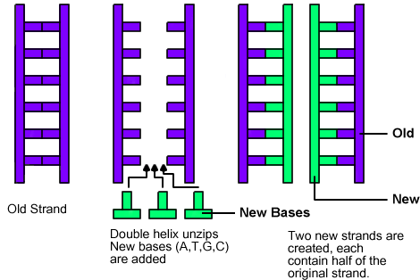

**F. What makes up our characteristics?**

* + - * If you have brown hair, what makes it brown, as opposed to blonde, or red?
        + A pigment called **melanin**, a ***protein****,* is what you see as “brown” in the hair.
      * What makes you tall or short?
        + The lengths of your bones are made up of a framework of **protein fibers.**
      * So, if heredity material controls your traits, and your traits are made of proteins, then shouldn’t heredity material control the making of proteins?
        + This is exactly what **DNA** does!!
        + The order of **nitrogen bases** (A,T,C,G) determines the type of **protein** that is assembled.
        + If the order of bases is accidentally changed, then **mutations** occur which can change the proteins that need to be made!

**III. THE LINK BETWEEN DNA & PROTEINS:**

* + - * In the **cytoplasm** of each cell, there are tiny organelles where proteins are assembled. What are they called?
        + **Ribosomes!**
      * If a hair cell needs to make melanin. How do the instructions to synthesize this protein get from the DNA to the ribosome?
        + Something must carry these instructions from the nucleus to the ribosomes in the cytoplasm. This “messenger” molecule is **mRNA!!**

**A. RNA (Ribonucleic acid):**

Comparing the STRUCTURE of DNA to RNA:

|  |  |  |
| --- | --- | --- |
| **STRUCTURE:** | **DNA** | **RNA** |
| Strands of nucleotides | **Double** | **Single** |
| Sugars | **Deoxyribose** | Ribose |
| Nitrogen Bases | **Thymine** | **Uracil** |

* 3 kinds of RNA:
  1. **mRNA** – messenger RNA (see picture below)
* *Structure:* **single stranded**
* *Function:* Carries the **DNA** message from the nucleus to the ribosomes
* **Codon** = set of three nitrogen bases representing an amino acid
  1. **tRNA** – transfer RNA (see picture below)
     + *Structure:* has an **anticodon** that is a complement to the **mRNA codon** at one end and a **amino acid** at the other end
     + *Function:* Carries the **amino acids** to the ribosomes for protein production.
  2. **rRNA** – ribosomal RNA
     + *Structure:* Apart of ribosome
     + *Function:* Creates the **peptide bonds** between the amino acids during protein production.

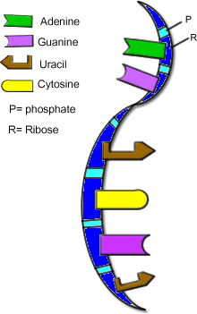

**mRNA**

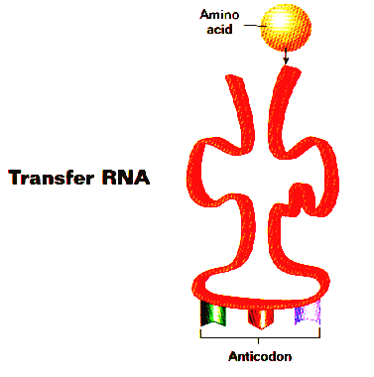

**IV. PROTEIN SYNTHESIS Overview:**

* + - The **protein** created is determined by the base arrangement in DNA (code sentence)
    - **DNA** transfers this information to **mRNA**, which carries the code to the ribosome where tRNA decodes it**. tRNA** anticodons base pair with mRNA’s codons. Then **rRNA** forms peptide bonds between **amino acids** to form a **protein**
    - The process of protein synthesis is broken down into two sub-processes: transcription and translation.

1. **Transcription** = is the process through which **DNA** transfers the code to **mRNA**

Takes place in the **nucleus**

1. **Translation** = is the process through which **mRNA** is decoded and forms a **protein**

Takes place at a **ribosome**

**A. TRANSCRIPTION- From DNA to mRNA:**

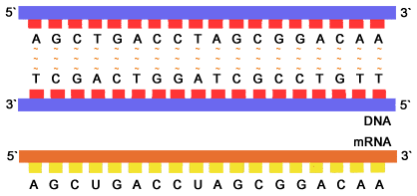

**1.** RNA polymerase (enzyme) attaches at a specific location on DNA

**2.** The enzyme then causes the DNA strands to separate from one another and allow one of the DNA strands to be **decoded**

**3.** mRNA nucleotides are floating around in the nucleus find their complement on the DNA stand and **bond** together. This is possible due to the base-pairing rules.

**4.** Once the DNA segment has been copied by the mRNA bases, the mRNA strand separates from the DNA

**5.** The mRNA (messenger RNA) leaves **nucleus** through a nuclear pore & enters the **cytoplasm**🡪 goes to **ribosomes** for protein synthesis

**6.** DNA zips up again to create the original double helix.

* **WHY is TRANSCRIPTION Important?**
  + It is needed to get the **DNA message** out of the **nucleus** so the ribosomes know what **protein** to make!
  + Without transcription, the ribosome would have no idea what proteins the body needed and would not make any.
  + You could **NOT** replace the hair that we loose every day; could NOT grow long fingernails; be able to fight off diseases; cells would fall apart because the proteins were not being **replaced**!!

**B. TRANSLATION (Protein Synthesis)-From RNA to Protein:**

**1.** First codon of mRNA attaches to ribosome.

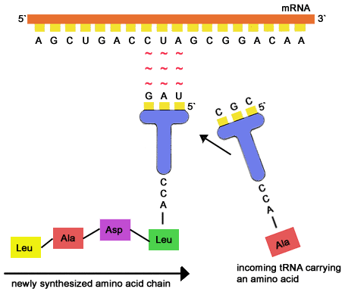

**2.** tRNA (transfer RNA)- each carries a specific amino acid; the tRNA anti-codon will pair up with its complementary mRNA codon.

**3.** When the 1st and 2nd amino acid is in place, the rRNA joins them by forming a **peptide bond**. As process continues, amino acid chain is formed until a stop codon.

**4.** The tRNA is recycled to find another of the same amino acid so the process can occur again and again.

**5.** The protein chains are then transported to other areas of the body that need them.

* **WHY is TRANSLATION Important?**
  + Makes all the **proteins** that the body needs
  + Without translation, proteins wound not be made and we could not replace the proteins that are depleted or damaged

C. SUMMARY of PROTEIN SYNTHESIS:

Below you will find the base sequence of a single strand of DNA. Please fill in the complimentary bases of mRNA, tRNA, and the correct amino acid sequence.

**\* NOTE: mRNA and tRNA never have T’s in the sequence! Always use the mRNA strand to code for the amino acids.**

**DNA** T A C **T T G** C A T **G G A** A T G **G T A** A C G **G T A** A C T **G**

**code**

**mRNA** A U G **A A C** G U A **C C U** U A C **C A U** U G C **C A U** U G A **C**

**code**

**tRNA** U A C **U U G** C A U **G G A** A U G **G U A** A C G **G U A** A C U **G**

**anticodon**

**Amino**

**Acids**

**Methionine (start)-asparagine-valine-proline-tyrosine-histidine-cysteine-histidine-stop**

###### DNA Review Worksheet

1. What does DNA stand for?_________________________________________
2. Where in a cell is DNA found?_______________________
3. What is the difference between chromatin and chromosomes?
4. How many PAIRS of chromosomes does a human have in their skin cells?________
5. A segment of DNA that codes for a protein is called a ____________________.
6. What are the three parts of a DNA molecule? Label the three parts of a DNA molecule in the picture provided.

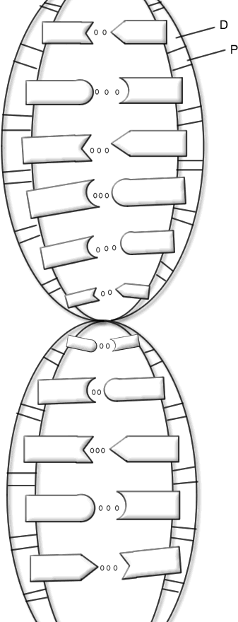

* 1. _____________________________________
  2. _____________________________________
  3. _____________________________________

1. What 4 bases make up DNA molecules?__________________________
2. Scientifically, describe the shape of a DNA molecule._________________
3. What type of bond holds together the nitrogen bases?_______________
   1. Label the hydrogen bond in the picture
   2. How many hydrogen bonds are found between A-T?_____ C-G?_____
4. What scientists are credited with the “base-pairing” rules?
   1. ________________________________
5. What are the base pairing rules?
6. Write the complementary stand to this DNA molecule on the line.

# G A T C C A T G A G T T A C

_________________________

1. What is the importance of the order of base pairs in a DNA molecule? (Hint: what might happen if the order of the base pairs were changed?)
2. When does DNA replicate? _________________________________
3. During DNA replication, what causes the hydrogen bonds to break?____________________
   1. What happens after the hydrogen bonds are broken?
4. What polymer makes up our characteristics (eye color, hair color, etc)? _____________________
5. The order of nitrogen bases (A,T,C,G) determines the type of ___________________that is assembled.

Protein Synthesis Review Worksheet

1. How are DNA and mRNA alike?
2. How are DNA and mRNA different? Fill in the table below.

|  |  |  |
| --- | --- | --- |
| **DNA** |  | **mRNA** |
|  | **Shape** |  |
|  | **Nitrogen bases** |  |
|  | **Sugars** |  |
|  | **Location** |  |

**Transcription: DNA to mRNA:**

1. How many strands of mRNA are transcribed from the two “unzipped” strands of DNA? __________
2. If the following were part of a DNA chain, what mRNA bases would pair with it to transcribe the DNA code onto mRNA? G-G-A-T-C-G-C-C-T-T-A-G-A-A-T-C

____________________________________

1. If DNA is described as a double helix, how should mRNA be described? ____________________
2. How are the accuracy of DNA and mRNA codes assured? _______________________________

**Translation: mRNA to PROTEIN:**

1. Name and describe the three types of RNA’s involved in protein synthesis?
2. What is located at EACH end of a tRNA molecule? ________________________________________
3. Where must an mRNA attach before protein production can begin?________________________
4. How many bases are needed to specify an mRNA codon?__________
5. If a strand of mRNA contain the sequence, U-A-G-C-U-A-U-C-A-A-A-U, what tRNA anticodons would be needed to translate the sequence?_____________________________
6. How does mRNA get out of the nucleus? _______________________________________________
7. What is the difference between an amino acid and a protein?_________________________________

_____________________________________________________________________________________

12. What type of bond is formed between amino acids?_____________________________

Protein Synthesis Flow Chart

Directions: Fill in the flow chart below, using the following words: **Amino acids, mRNA, mRNA codon, nucleus, nuclear pore, peptide bonds, ribosome, transcription.**

The first part of protein synthesis is

Takes place in the

Where DNA is decoded onto

Leaves through a

Goes to a

The 2nd part of protein synthesis is

Where

tRNA anticodons bond with

Then

rRNA

creates

between

Creating a

PROTEIN