Name:_______________________________________________Date:____________________Per.___

Safety Rules in the Classroom
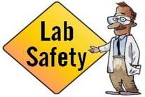
- Always follow safety procedures given by your TEACHER.

- Never put any materials, including chemicals, in your MOUTH.

- Do not SMELL any unknown material. If your teacher asks you to smell a substance, do not stick your nose to it. Wave a hand over it to make the scent come up to your nose.

- Avoid touching your FACE, MOUTH, EARS or
EYES when working with chemicals, plants, or animals.

- Do not MIX unknown chemicals just to see what might happen.

- Always WASH your hands immediately after using chemicals.

- Clean up your WORK SPACE/DESK after each investigation.

- Be careful when using SHARP or POINTED tools.
Protect your eyes and those of your classmates.

- Report all ACCIDENTS to your teacher, even small ones.

- Follow DIRECTIONS, ask QUESTIONS if you are unsure of what to do, and
BEHAVE responsibly!

