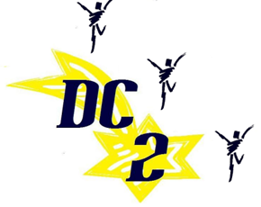

March 23, 2016

Dear Parents/Guardians:

For the upcoming show we are asking all of the female dancers to have the following costumes:

* Black footless tights and black short-sleeve leotard
* Black leggings or jazz pants
* Black Biker shorts

We are asking the male dancers to have the following costumes:

* Black sweat pants
* Black short sleeve t-shirt
* White button up shirt
* Black dress pants

We are asking ***all*** of the dancers to sell 5 adult tickets for the show on Friday, April 22, 2016. The tickets cost $10.00 for adults. Tickets for students are $5 with student ID at the door.

We are also asking that all of the dancers to contribute $50.00 to cover expenditures such as the cost of food the night of the show, (DC2) dance t-shirt, costumes and extra practices. We asked that you make monetary donation no later than March 31, 2016.

If you have any further questions please email me at, [l.manning@hackensackschools.org](mailto:l.manning@hackensackschools.org) . Thank you and I look forward to seeing you at the show.

Sincerely,

Lori Manning