10.1 – Square Root Functions

Graph  and compare to the parent graph.

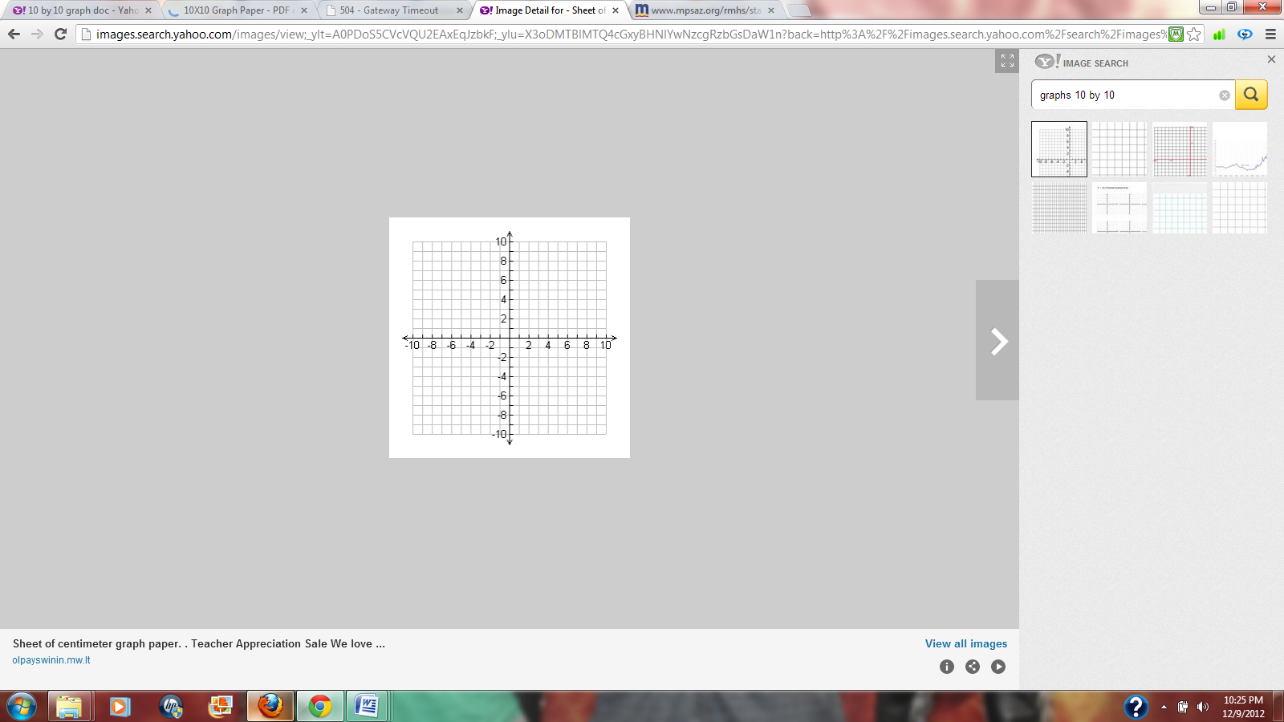

|  |  |
| --- | --- |
| x |  |
|  |  |
|  |  |
|  |  |
|  |  |

Domain: __________________

Range: ____________________

Description: __________________

10.2 – Simplify Radical Expressions

1.  2.  3. 

4.  5.  6. 

7.  8.  9. 

10.  11.  12. 

10.3 – Operations with Radical Expressions

1.  2.  3. 

4.  5. 

6. 

* 1. Radical Equations

1.  2.  3. 

4.  5. 