NAME: __________________________ PERIOD _____ DATE_________

watch the youtube video and then answer the following questions.

**Intro to 3D modeling Part 1**

<https://www.youtube.com/watch?v=k97ZzH72scs>

1. What workspace should you use for 3D modeling?
2. When in default settings for World Coordinate System, in which direction do the axis appear?
   1. X-axis
   2. Y-axis
   3. Z-axis
3. What is the “left hand rule”?
4. Explain the invisible drawing boundaries and how to create it?
5. Define the following Function keys, 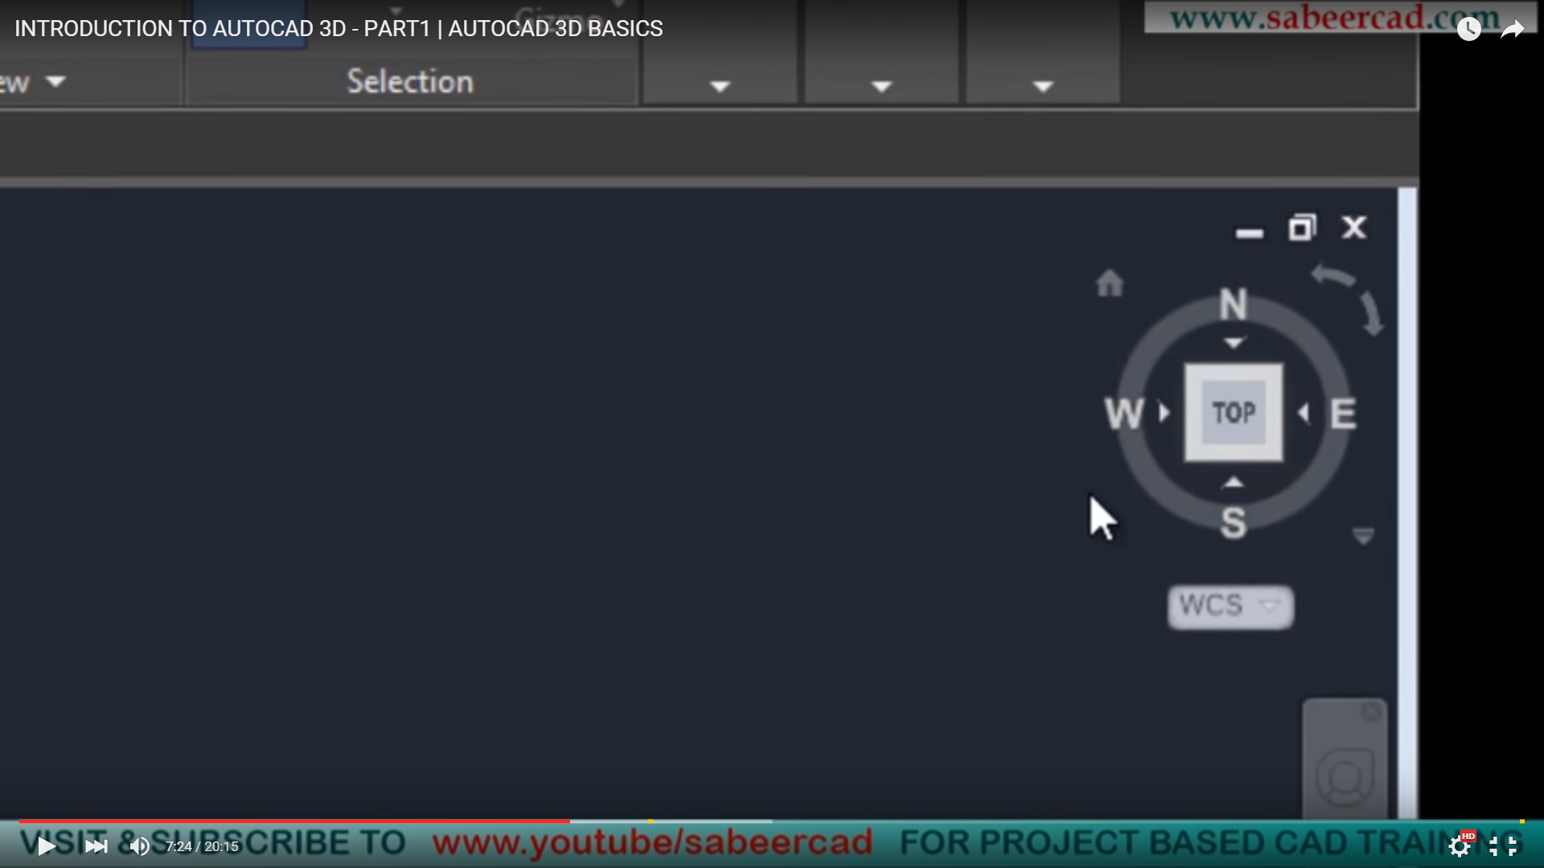
   1. F7
6. 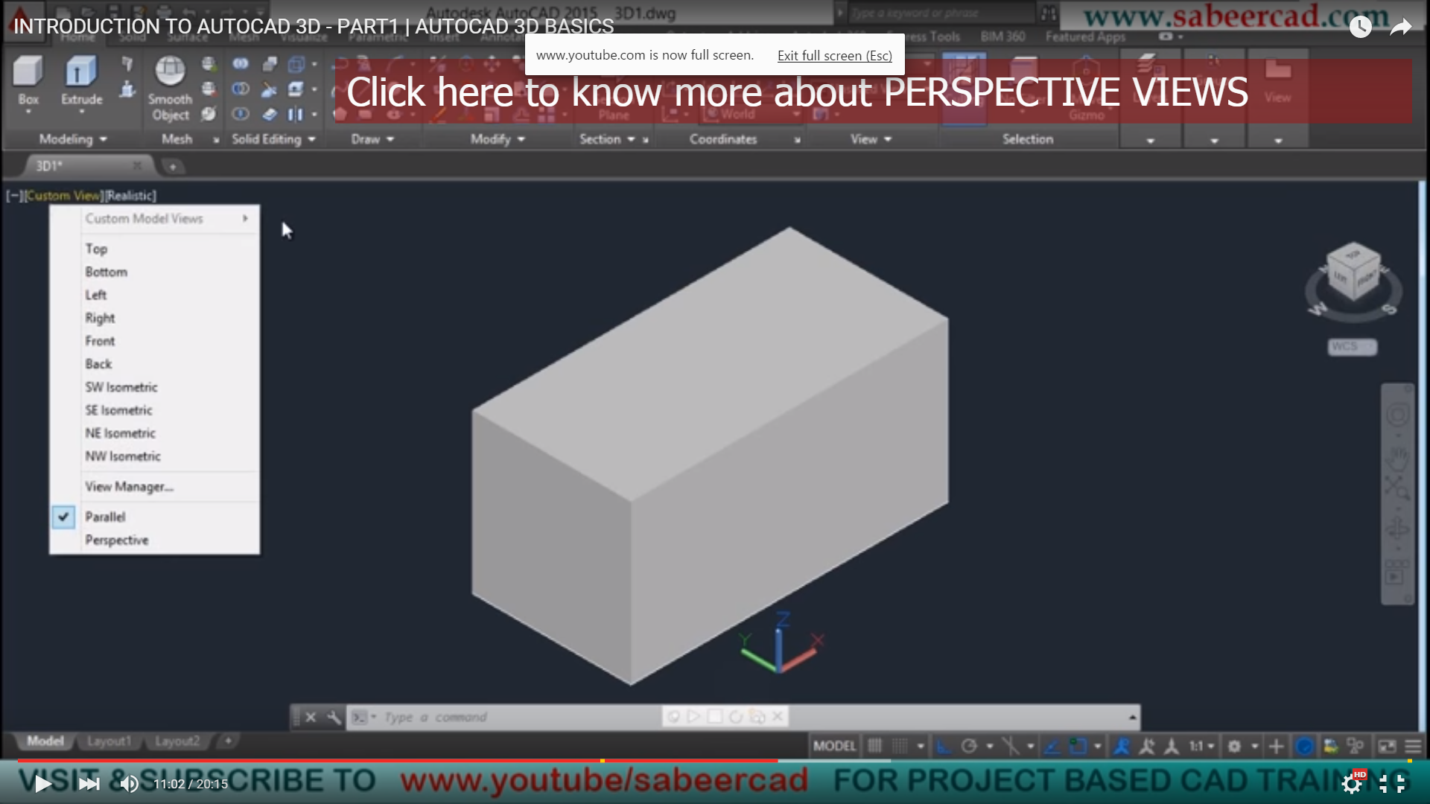Define Extrusion.
7. What’s the view cube’s function?
8. What are hotspots?
9. What is the tutorials explanation of SW Isometric view’s importance?
10. Explain each of the Visual Styles listed.
    1. 2D Wireframe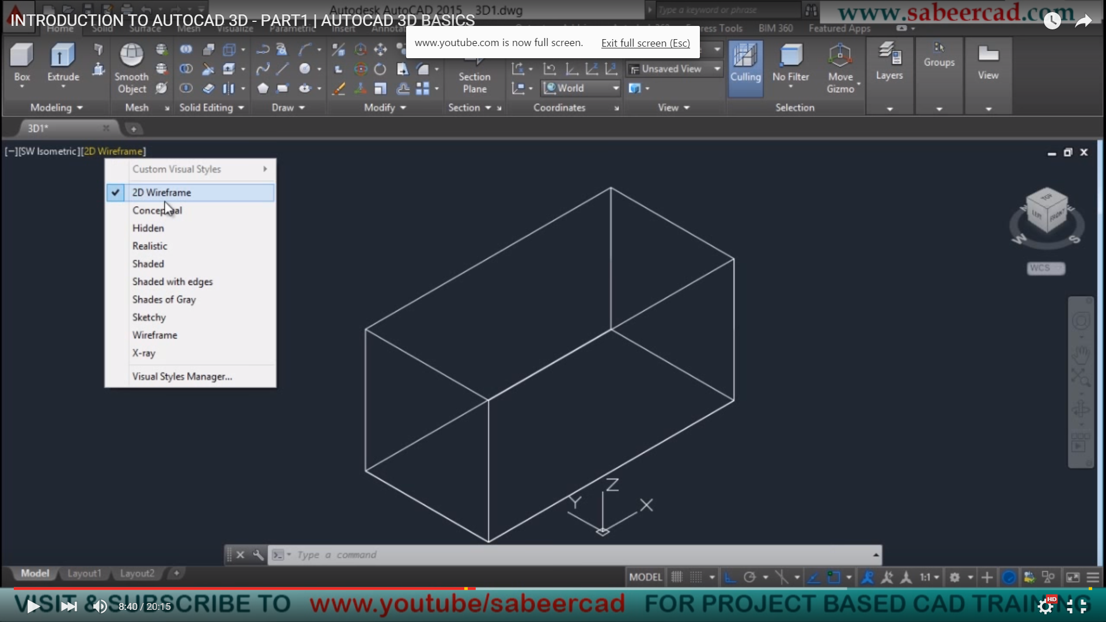
    2. Conceptual
    3. Hidden
    4. Realistic
    5. Shaded
11. What’s the Perspective effect?
12. Where do you toggle to turn on the old pull down menus?
13. Explain what an Auxiliary View is?
14. How many sub-screens can you have by using Viewport configuration.
15. WCS is?
16. UCS is?
17. Explain 2 main functions of the Navigation Bar.
18. Rewind option of the Navigation Bar allows you to _______________.
19. How do you save a view?
20. Before we generate a particular view, what should be set first?