1. Graph the Functions 
2. What is the equation for the axis of symmetry? A) ______________________
3. What is the vertex? B) ______________________
4. What is the y-intercept? C) ______________________
5. Is the vertex a minimum or a maximum? D) ______________________
6. State the Domain and Range of the function. E) Domain: _______________

Range: ________________

1. What are the x-intercepts (as coordinate pairs)? F) ______________________

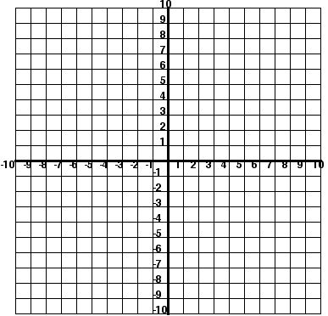

G)

1. Graph and label all above and 6 additional points using a table.
2. Graph the Functions 
3. What is the equation for the axis of symmetry? A) ______________________
4. What is the vertex? B) ______________________
5. What is the y-intercept? C) ______________________
6. Is the vertex a minimum or a maximum? D) ______________________
7. State the Domain and Range of the function. E) Domain: _______________

Range: ________________

1. What are the x-intercepts (as coordinate pairs)? F) ______________________



G)

1. Graph and label all above and 6 additional points using a table.